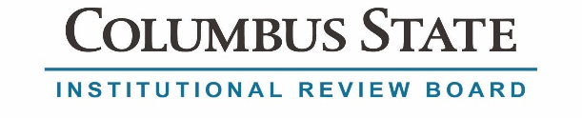

Institutional Review Board Authorization Agreement Request
Institutional Review Board (IRB) Authorization Agreements allow one IRB to rely on another IRB for review and approval of research projects. The Columbus State IRB will cede authority only to institutions with a valid federalwide assurance (FWA). For more information about authorization agreements, see the Columbus State Community College IRB Standard Operating Procedures on the IRB website. Columbus State IRB FWA# 00010584.
If you request that Columbus State serve as the Relying IRB:
- Complete questions 1-7 below.
- Submit this form along with the following documents:
  - The study protocol/application
  - All study consent documents
  - Evidence of formal training (e.g. CITI)
  - Approval letter from the IRB of Record (if pending, submit approval letter when available)
If you request that Columbus State serve as the IRB of Record
- Complete questions 1-4 below.
- Submit this form along with a new IRB protocol application or a request for modification to add a site/investigator(s) to an existing protocol.
- The IRB of Record is the IRB that will review/approve the collaborative research project. The Relying IRB is the IRB that will rely on the review/approval of the IRB of Record. This means that the Relying IRB will not review/approve the project.
Requested IRB of Record: Click here to enter text. Federalwide Assurance (FWA) #: Click here to enter text.
Requested Relying IRB: Click here to enter text. Federalwide Assurance (FWA) #: Click here to enter text.
- Reason for requesting this IRB of Record: Click here to enter text.
- This agreement is limited to the following specific research project.
Name of Research Project: Click here to enter text.
Name of Principal Investigator: Click here to enter text.
Home Institution: Click here to enter text.
Email Address of Principal Investigator: Click here to enter text.
Sponsor or Funding Agency (enter N/A, if none): Click here to enter text.
If funded, Primary Awardee Institution: Click here to enter text.

- Contact information for the collaborating institution’s IRB. This is the person who should be copied on all correspondence regarding the research project.
Contact Person: Click here to enter text.
Email Address: Click here to enter text.
Phone Number: Click here to enter text.

Complete questions 5-7 if you request that the Columbus State IRB serve as the Relying IRB:

- The research project will involve the following populations:
☐ Columbus State students
☐ Columbus State employees

- Briefly describe Columbus State’s role/activities in the research. Click here to enter text.

- List all Columbus State research team members or other personnel involved in or facilitating the research.
Click here to enter text.

Approved for execution of the agreement: _______________________________________ Date: ______________

