Types of myPLAN goal categories
Type/Weight | Activity description and ideas for how to document
Key Responsibility | Key responsibilities are your core job duties that are consistent with your job description. Any service or function that you maintain on a routine basis is a key responsibility.
How to Document (examples)
How much; how often; any feedback received; notable events, challenges or accomplishments; changes in how you do the work; your contributions; how competencies are demonstrated through your work.
Projects & Strategy | Working on a new initiative? Have a goal executes college or department strategy? Examples include: developing or significantly revising a program, service or event; learning and implementing a new system or practice; conducting research for continuous improvement.
 | How much of the project has been completed; notable events, challenges or accomplishments; the impact of the project; your contributions; how it contributes to the department and/or college goals; how competencies are demonstrated through your work.
Professional Development Goal | Can be: any learning activity to improve your work-related knowledge or skills; academic work supported by College few waivers or tuition assistance; Non-academic learning that is College-led or sponsored; learning at external conferences and workshops; self-directed study.
 | What you have done to learn and grow; training attended and/or credential earned; describe where and how you have applied this learning; how learning contributes to the department and/or college goals. How learning has improved global or job-specific competencies.
Service & Engagement | Any work that supports the mission and goals of the College that is outside of your key responsibilities or projects & strategy goals. Examples: serving on committees, volunteering for events, involving your department in "First 4 Weeks" and similar activities The work can be formally sponsored by the College or a product of your own initiative.
 | Identify your service activities; what you did; duration of activities; how they support the college.

Create Goals with the Goal Library
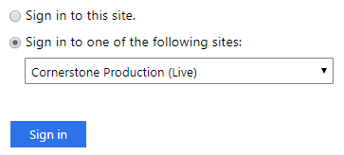
Log in to cornerstone.cscc.edu. Select “Cornerstone Production (Live)” from the dropdown and enter your FULL Columbus State email and password.

1. Go to the
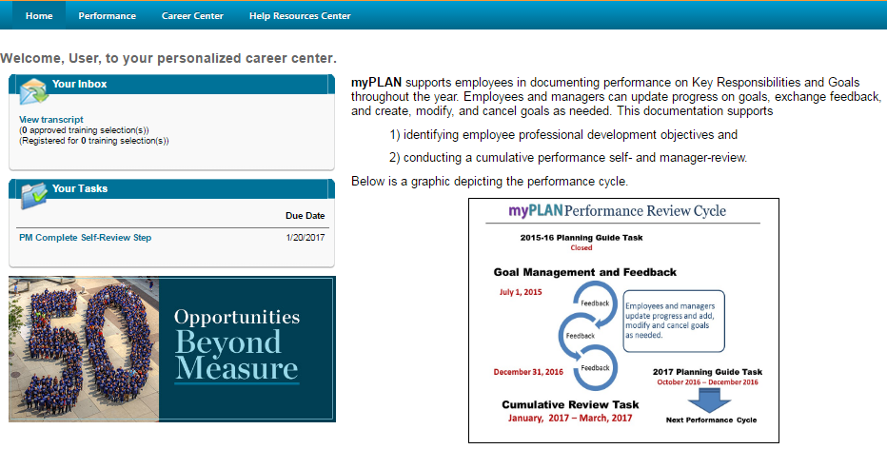
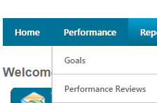
Hover over performance then choose Goals.
goals area.

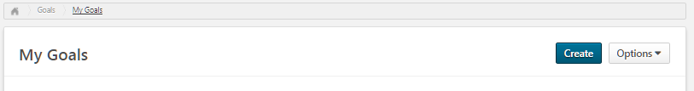
2. Choose “Create”

and then, within the
goal editor, select
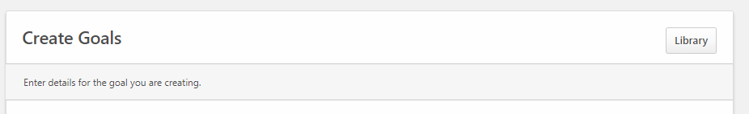
“Library.”

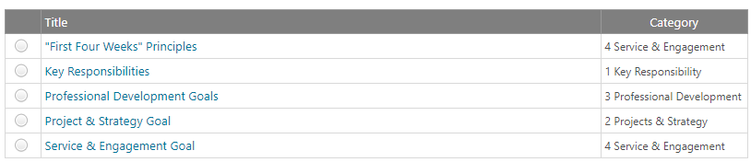
3. Select a template. (There may be multiple for a category the number may change throughout the year.)

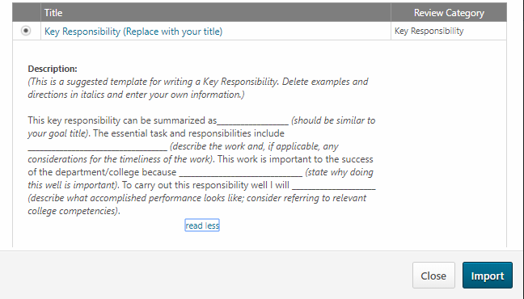
4. Click on the goal title to see the complete goal template.
Click “Import” to copy the goal into your goal editor.

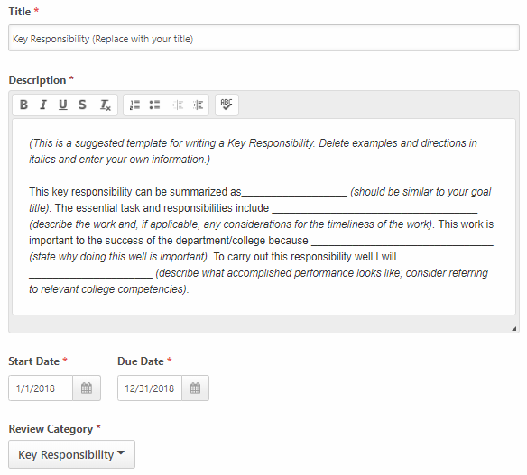
5. Edit the goal template by adding your own information.
Remember to change the Title and adjust the date range.
Submit the goal to make it active or “Save as Draft” to work on it later (submitted goals can be edited).

Tips:
Don’t feel obligated to keep the same wording in the templates. Use these as a guide and adapt the structure to meet your needs.
We recommend new employees set short-term goals (60-90 days) relevant to learning their new jobs. More complex and longer term goals can be added at any time.

