Navigating your Transcript
Log in by going to Cornerstone.cscc.edu. You will be taken to a sign-on page for various college systems. The default system is Cornerstone Production (live). Log-in with your college username and password. (If you don’t know your username and password, go to password.cscc.edu or call the IT Help Desk as 614-287-5050.)
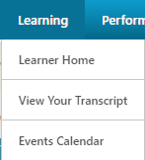
---------------------------------------
Locate “View Your Transcript under the Learning tab. All current and historical learning activity is recorded on your Transcript. Use it to:
- see what training you are registered for or are currently taking,
- Complete online courses, materials & quizzes
- read descriptions and other training details,
- add external training to your transcript
- access training evaluations and completion certificates (if applicable)
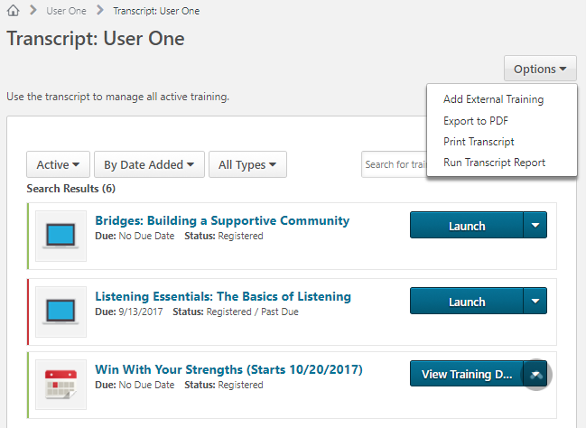
Trancript Overview
See the “External Training Form Guide” in the Help Resources Center.

“Active Training” displays training for which you are:
- Registered
- In Progress
- Past Due

Click “Launch” to start/resume online training.
Click the training Title or “View Training Details” to see course or session details.

“Training Details” displays:
- Description
- Contact
- Date and Time
- Location
- Other information

Navigating Curricula
(Example: Adjunct Orientation)

Curricula are composed of a collection of training items that may be the same or different types (ie. online modules, materials, in-person sessions, etc.) Clck “Open Curriculum” to see all components.

Below is an incomplete example of a curriculum. This shows two materials and a quiz. Depending on the intent of the content owner, some curricula may force you to follow a sequence of content, others may let you complete content in any order. Typcially, unless specified otherwise, all content items must be completed before you receive credit for completing the curriculum. Click “Launch” to open materials, online modules or quizzes. (In the example below, the Quiz has already been taken, so the default option is to review it.) A completed item will have a checkmark added to its icon.

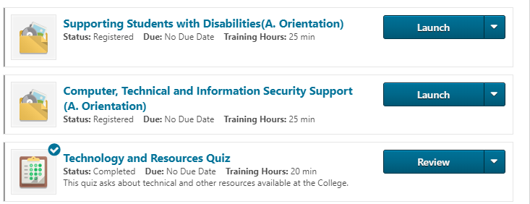

After opening and reading a material you must return to your transcript and mark that item complete to receive credit.
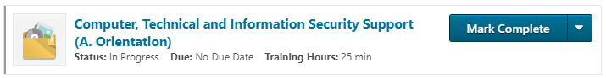

Completed Training
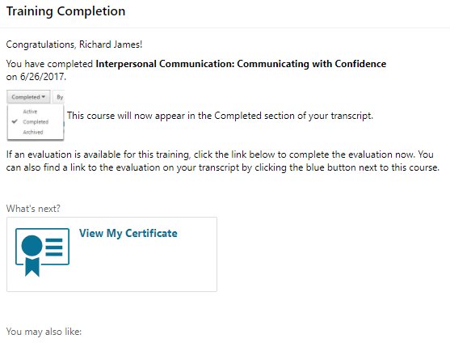
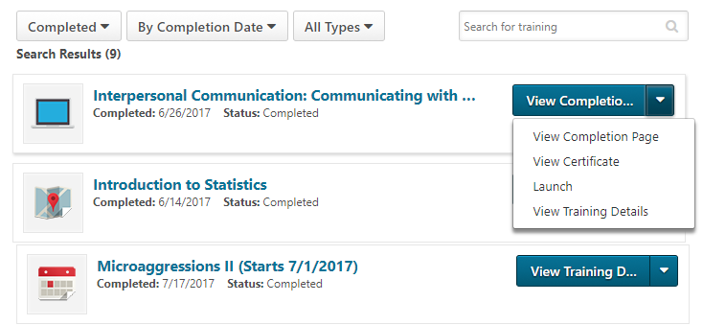
You will know the system has recognized your completed training when the training item moves to the Completed section of your transcript and you receive a competion confirmation email to your college email address.
Some completed training will have a Training Completion Page. Select “View Completion Page” from the drop-down menu. This page indicates the date you completed the training and, if available, links to your certificate, an evaluation, and any recommended training.
There is no need to forward a certificate as proof of training. Your transcript is your training record.

“Completed Training”
In order for training to display as completed:
- All required steps must be completed, including:
- Any required pre- and post-work
- Any required evaluations
- The instructor or training contact must mark you as having attended any in-person sessions.

