SOC 2410- CRIMINOLOGY
TERM: AU 23

Instructor: Amy Ng, Ph.D.
Phone: 614-287-2825 (Office) and 614-859-5335 (Cell) Email: ang@cscc.edu
Meeting Times: Online
OFFICE HOURS:

Office Hours: Mon and Wed from 11am-12pm est. located in TL 340 or online via zoom Friday from 11am-3pm est.
Textbook:
Criminology: The Core. This is embedded into your classroom.

Course Description
The purpose of this course is to introduce the student to the sociological study of criminology by examining fundamental issues of the discipline such as the nature and social distribution of crime, the criminal law, and theories of crime. The primary focus of the course is on understanding theories surrounding the causes and correlates of criminal behavior and developing a critical perspective from which social policies on crime can better be understood. This course is a foundation for all other courses in criminology.

Course Objectives:
Students should be able to demonstrate an understanding of:
Provide the history of criminology and its various forms (e.g. classical criminology)

Compare and contrast the major theoretical explanations of crime and discuss their implications

Discuss the impact of different criminological explanations on the development of public policy
Compare and contrast the different ways to measure crime, including official, self-report and victimization measures
Analyze various crime patterns and trends

Demonstrate an understanding of the issues faced by the victims of crime

General Learning Outcomes:
Critical Thinking Quantitative Skills Scientific Literacy
Communication Competence Cultural and Social Awareness

Late Policy for Assignments*: No late work will be accepted without prior *******See Department and College Policies on Blackboard******

Course Policies:
1. Student Conduct: When respect breaks down, the learning process is interrupted. This includes the use of cell phones or other devices in a manner that disrupts the classroom environment. Students must be respectful of others and the instructor. Students must abide by the student code of conduct rules (see student policy 7-10). See the link to the student handbook: Offhttp://www2.cscc.edu/services/studenthandbook/StudentPolicyProced.pdf .
2. Attendance: Students are expected to participate in the online class multiple times per week. All weeks begin on Monday at midnight and end on Sunday at midnight. However, week 16 will end on Thursday at midnight to allow for grading. Students who miss more than one week generally find themselves falling behind and struggling to keep up with the material and meeting deadlines.

3. Exams*: Students have 1 week to take tests, quizzes, and exams. All exams and quizzes will be online via blackboard and can be taken at home. Students who miss an exam should contact the instructor within 24 hours and have a valid written documented excuse to take a make-up exam. If you know ahead of time that you will not be able to attend an exam due to a planned out of town trip for work or military, you must provide two weeks’ notice with written documentation. You will have 2 hours to complete both exams.

4. Approval from the instructor, or under exigent circumstances with documentation.

5. Grading: Please allow up to10 days for all grades to be returned via Blackboard after the due date.
*Exigent circumstances will be considered.

Course Requirements
Two Exams@ 75 points each (Testing Center) | 150 points (30%)
5 Discussion Boards @ 25 points each | 125 points (25%)
4 Quizzes@ 25 points each (Blackboard) | 100 points (20%)
5 Assignments/ Essays @ 25 points each | 125 points (25%)
TOTAL | 500 points (100%)
Exams
- Multiple choice, fill in the blank, and essay exams will be administered at home.

Quizzes
- Quizzes are given on blackboard, see policies on missed exams above. Students will have 1 hour to complete the quizzes. All quizzes will be open on Monday at midnight and close on Sunday at 11:59pm est. The quizzes will be located under the quiz tab on Blackboard.

Discussion Boards
- Discussion boards will be completed via blackboard. Each week students will complete one assigned discussion board answering each question and post at least two peer responses. All main posts should be 150 words in length and cite outside sources using APA format. All peer responses have no word or citation requirement but should be substantive. Go beyond nice work or good job. Please see policies on late discussion boards above.

Assignments/ Essays
- All in class assignments are due by Sunday at 11:59pm est. Please view all assignment instructions under the assignments tab. All assignments must be at least 250-500 words in length and use correct APA formatting. Email assignment submissions will not be accepted. Please submit each assignment under the correct assignment submission area.

See the grade scale below:

A | 450-500
B | 400-449
C | 350-399
D | 300-349
E | 299 or less

Course Schedule
The Schedule is subject to minor modification.

Week 1 | 8/28-  9/3 | Chapter 1 | Defining Criminology | Complete Week 1 DB
Week 2 | 9/4-  9/10 | Chapter 2 | Measurements | Complete Week 2 Quiz
Week 3 | 9/11-  9/17 | Chapter 3 | Victimization | Complete Homework 1
Week 4 | 9/18-  9/24 | Chapter 4 | Rational Choice | Complete Week 4 DB
Week 5 | 9/25-  10/1 | Chapter 5 | Trait Theory | Complete Week 5 Quiz
Week 6 | 10/2-  10/8 | Chapter 6 | Social Structure Theories | Complete Homework 2
Week 7 | 10/9-  10/15 | Exam 1 (At home exam) | Review | Complete Exam 1
Week 8 | 10/16-  10/22 | Chapter 7 | Social Process Theories | Complete Homework 3
Week 9 | 10/23-  10/29 | Chapter 8 | Conflict Theories | Complete Week 9 DB
Week 10 | 10/30-  11/5 | Chapter 9 | Developmental Theories | Complete Week 10 Discussion
Week 11 | 11/6-  11/12 | Chapter 10 | Violent Crimes | Complete Week Homework 4
Week 12 | 11/13-  11/19 | Chapter 11 | Terrorism and Political Crimes | Week 12 Quiz

Week 13 | 11/20-  11/26 | Chapter 12 | White Collar and Corporate | Complete Homework 5
Week 14 | 11/27-  12/3 | Chapter 13 | Public Order | Complete Week 14 DB
Week 15 | 12/4-  12/10 | Chapter 14 | Cybercrime | Complete the week 15 quiz
Finals Week | 12/11-  12/16 | Exam 2 (Final Exam)  You have until Thursday (close) to take the exam.
Last day to drop the course without a W is: 9/18/23

**For the purposes of financial aid reporting, a student meets the participation and attendance criteria if s/he has actively engaged in the class and demonstrated a meaningful attempt toward completion of the course. Examples of active engagement may include, but are not limited to: completing a graded course assignment (e.g., homework, quiz, essay, project, or lab); actively participating in studio or practicum sessions; making content-related contributions to an online discussion forum (including responses both to prompts and to student/instructor posts).

Core Knowledge Examples:
1a. Historical overview assignment example:

Objective: This assignment explores the early development of criminology as an academic discipline, focusing on its origins, defining moments, and the evolution of its definitions. It aims to provide students with a comprehensive understanding of how criminological thought has been shaped over time.

Instructions:

  - Introduction to Criminology: Start by presenting a concise definition of criminology. Explain its scope and significance in understanding crime, criminal behavior, and the criminal justice system.
  - Historical Context: Trace the origins of criminological thought, focusing on the Enlightenment period. Discuss how thinkers like Cesare Beccaria and Jeremy Bentham contributed to the emergence of criminology with their ideas on law, punishment, and the social contract.
  - Early Theories and Developments: Highlight key early theories that laid the groundwork for the field, such as classical criminology and its emphasis on rational choice and deterrence.
  - The Role of Sociology in Criminology: Discuss how criminology began to incorporate sociological perspectives, examining how societal factors influence criminal behavior.
  - Defining Criminology: Reflect on how the definition of criminology has evolved from its early focus on crime and punishment to include broader considerations like social justice, prevention, and the role of the criminal justice system.
  - Conclusion: Summarize the importance of understanding the early development of criminology and its impact on contemporary criminological theories and practices.

Format:

    - Length: 750-1000 words
    - Citation Style: APA or MLA
    - Include at least three scholarly sources.

Evaluation Criteria:

    - Comprehensive understanding of the historical development of criminology.
    - Ability to articulate the evolution of criminological definitions.
    - Quality of analysis and engagement with historical perspectives.
    - Clarity of writing and adherence to formatting guidelines.

Understanding Criminal Statistics Assignment Example:

- Go to the FBI’s Uniform Crime Report website (start at FBI.gov). Click on the UCR for the most recent year available. Fill in the following information based on national totals:

Crime in the US | Number Reported | Rate per 100,000
Murder
Rape
Robbery
Assault

- Fill in the following information for the city or town in which you were currently live:

Crime in | Number Reported | Rate per 100,000
Murder
Rape
Robbery

Assault

- Fill in the following information for

Crime in Flint, MI | Number Reported | Rate per 100,000
Murder
Rape
Robbery
Assault

- Which city has the higher crime rate, Flint, MI or your hometown?

- List 3 reasons why crime rates might differ in those two cities/towns:

1.
2.
3.

- Now go to the Bureau of Justice Statistics website (bjs.ojp.usdoj.gov). Go to the section on violent crimes and scroll down to find the report called “Criminal Victimization” for the latest year available and fill out the following information:

Crime in the US | Number Reported | Rate per 1,000
Rape
Robbery
Assault

- Why do we not have a measure for murder in the National Victimization Surveys?

- Is the victimization rate higher or lower than the FBI’s UCR crime rate? (check the correct answer)

  - Higher ☐

  - Lower ☐

Why is it higher/lower?

- Go to the US Census Bureau’s website (census.gov). Find and click on “American FactFinder” and fill in the following table:

 | Columbus, OH | Flint, MI
% Individuals below poverty level

- ​Now, go to crimereports.com and type in Columbus Ohio in the address bar. In the data range field, select a three month time frame. In the incident layers field, choose only homicide. Now, look at the mapped homicide incidents. Knowing what you know about Columbus, describe the areas where homicides are occurring in Columbus.

- BONUS: If you wanted to know more about the geography of poverty and homicides in Columbus, what other information do you think you would need? List at least 3.

1.

2.

3.

Victimization Assignment Example

In 250- 500 words or more complete the following:
Go to http://www.rateyourrisk.org/ and complete all three tests. Discuss the following in 250-500 words or more:
- What were your specific numbers for each test?
- Provide a brief overview of the report.
- What can be done to reduce your risk of victimization.
- If your level of victimization was high, which theory of victimization could lead to your victimization?
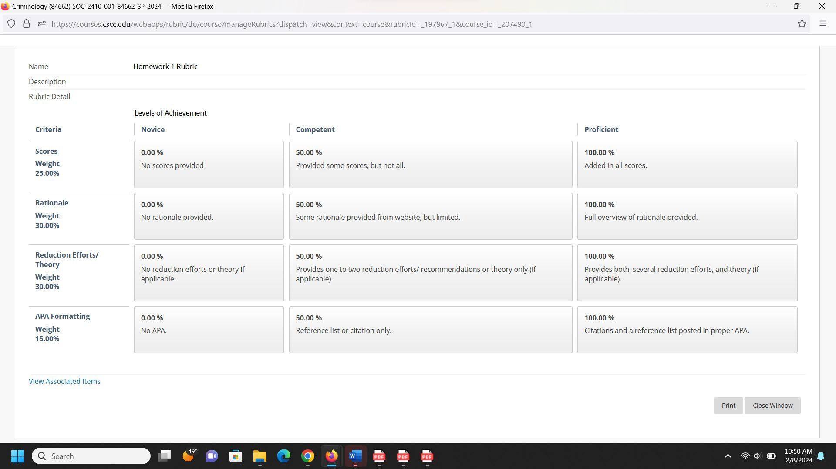
Be sure to use proper APA formatting. Grading Criteria:

Theory Assignment Example:

Assignment Title: Analyzing Strain Theories in Criminology

Objective: This assignment aims to compare and contrast different strain theories within criminology, assessing their key propositions, similarities, and differences, and evaluating their contributions to understanding criminal behavior.

Instructions:

- Introduction: Briefly introduce strain theories, explaining their significance in criminological theory and their common premise that social structures can pressure individuals into committing crimes.
- Main Strain Theories: Discuss the following main strain theories:
  - Merton’s Strain Theory: Outline Robert K. Merton’s theory focusing on the societal pressure to achieve economic success without equal opportunity, leading to strain and, consequently, criminal behavior.
  - General Strain Theory (GST): Describe Robert Agnew’s extension of strain theory, emphasizing multiple sources of strain including the removal of positively valued stimuli and the presentation of negative stimuli.
  - Cohen’s Subcultural Strain Theory: Discuss Albert K. Cohen’s focus on the response of lower-class youth to status frustration, resulting in the formation of delinquent subcultures.
- Comparison and Contrast: Compare and contrast these theories in terms of their conceptualization of strain, the causes of strain they identify, their proposed mechanisms linking strain to crime, and the types of crime they best explain.
- Critical Evaluation: Critically evaluate the strengths and limitations of each theory, considering empirical support, theoretical consistency, and applicability to various types of crime and populations.
- Conclusion: Summarize the insights gained from comparing and contrasting these strain theories and their utility in explaining criminal behavior.

Format:

- Length: 1000-1500 words
- Citation Style: APA
- Include at least five scholarly sources.

Submission Deadline: [Insert Date]

Evaluation Criteria:

- Depth of understanding of strain theories and their key components.
- Ability to critically compare and contrast the theories.

- Clarity of argument and coherence in writing.
- Proper citation and adherence to academic standards.

Real world application assignment:

Assignment Title: Analyzing White-Collar Crime through Cinema

Objective: This assignment encourages a deeper understanding of white-collar crime by analyzing its portrayal in film. Through critical engagement with cinematic representations, students will explore theoretical explanations for these crimes and consider effective prevention strategies.

Instructions:

- Film Overview (300 words): Select a film that depicts white-collar crime, such as "Wall Street," "The Wolf of Wall Street," "Office Space," "The Martha Stewart Story," or "Boiler Room." Provide a concise summary of the film, focusing on its portrayal of white-collar crime. Highlight the key criminal activities and the characters involved.
- Theoretical Analysis (400 words): Discuss the motivations behind the white-collar crimes depicted in the film. Apply at least two criminological theories to your analysis. Use your textbook and at least two scholarly sources to support your argument. This section should explore how the film reflects the theoretical underpinnings of white-collar crime, such as rational choice theory, strain theory, or differential association theory.
- Prevention Strategies (300 words): Based on your understanding of the film and the theories discussed, propose comprehensive strategies for preventing white-collar crime. Consider both legal measures and ethical guidelines that could be implemented at organizational and societal levels to mitigate such crimes.
- Critical Reflection (200 words): Reflect on the portrayal of justice and the legal system in the film. Consider the implications of the film's message on public perceptions of white-collar crime and its impact on real-world policy and societal attitudes.

Formatting and Submission Guidelines:

  - Total Length: 1200-1300 words
  - Citation Style: APA OR MLA format for all in-text citations and references
  - References: Include a minimum of three scholarly sources, in addition to the film and your textbook.

Deadline: Evaluation Criteria:
  - Depth of analysis in applying criminological theories to the film
  - Originality and feasibility of proposed prevention strategies
  - Critical engagement with the film's portrayal of justice and white-collar crime
  - Clarity, coherence, and academic rigor in writing and formatting

1b. Core Knowledge Exam Question Examples:

theory suggests that people can only learn techniques and attitudes of crime from close relationships with criminal peers.

Answer: Control Theory

Of the drug control strategies, evaluations of drug education programs have shown the most effectiveness as reducing drug use.

Answer: False

As a result of theory, sentencing policy changes have included the introduction of three strikes laws, mandatory minimum sentencing, and a continued use of the death penalty.

Answer: Classical

Considering Routine Activities Theory, analyze the significant rise in cybercrime rates during the global COVID-19 pandemic. Discuss how the elements of a motivated offender, suitable target, and lack of capable guardianship have contributed to this trend. Provide real-world examples to support your analysis.

Theory Examples:

2a. Assignment Title: Applying Institutional Anomie Theory to Real-World Issues

Objective: The goal of this assignment is to critically analyze a contemporary social issue through the lens of Institutional Anomie Theory (IAT). By examining a real-world example, students will explore the dynamics between societal institutions and their contribution to anomie and deviance.

Instructions:

  - Introduction to IAT: Briefly summarize the main components of Institutional Anomie Theory, emphasizing the theory's perspective on how the economy influences other social institutions (family, education, and polity), leading to anomie and deviance.
  - Real-World Example - The 2008 Financial Crisis: Research the 2008 financial crisis, focusing on its origins, key events, and societal impacts. Describe how deregulation, emphasis on economic success, and the undermining of regulatory institutions exemplify the principles of IAT.
  - Application of IAT: Analyze the 2008 financial crisis using IAT. Discuss how the overemphasis on the economic institution led to the erosion of norms (anomie) and contributed to widespread deviant behavior (e.g., excessive risk-taking by banks, mortgage fraud). Consider how other social institutions, such as the family and education system, were impacted by this economic crisis.

  - Reflection: Reflect on the implications of IAT in understanding the financial crisis. How does this theory help explain the societal changes and challenges that followed? What lessons can be learned regarding the balance between economic goals and the functions of other social institutions?

Format:

    - Length: 1000-1500 words
    - Citation Style: APA or MLA Format
    - References: Include at least five scholarly sources

Submission Deadline:

Evaluation Criteria:

    - Understanding of Institutional Anomie Theory and its components
    - Depth of analysis in applying IAT to the 2008 financial crisis
    - Ability to synthesize information from various sources
    - Clarity of writing, argumentation, and adherence to formatting guidelines

2b. Example exam questions:
The presence of strain is said to lock people into an independent with unique values and beliefs.
Answer: Subculture
theory is credited to Cloward and Ohlin and is a combination of strain and social disorganization principles relating to gang sustaining criminal subcultures.
Answer: Differential Opportunity
who focuses on state (organized) crime contends that a government might go to war to support the capitalist classes who need the wealth and resources of other nations.
Answer: Critical Criminologists

Complete the following in 200 words or more:
Maria Efron is a 28-year-old shopping addict. She spends every dime earned on shopping, often leaving her bills and financial obligations unpaid. If she does not have the money to shop, she will often steal. Discuss the biological and psychological theoretical approaches that have a possible influence on her behavior? Be sure to define the theory and provide specific examples to support your ideas.

attempt to explain the natural history of a criminal career encompassing its onset, continuation, and termination.
Answer: Developmental
Briefly define the difference between active and passive precipitation. Think of an example for each to support your discussion.

Methodology Examples:
3a. Quiz Sample Questions:
Criminologists interested in computing criminal statistics focus on creating measurements of criminal behavior.
Answer: valid and reliable
In your own words briefly compare and the differences between qualitative and quantitative research.

3b. Exam question:
In 300 words or more answer the following: Using the scientific method develop a research project that you would be interested in conducting in Criminology using the scientific method. Begin with a research question based on an appropriate theory. Then discuss how you would collect and measure data, as well as provide an initial hypothesis. Then briefly discuss why are interested in the research project.

Values Examples
4a. Discussion board prompt:
Considering the Conflict Theory's perspective on how societal power dynamics influence crime and justice, reflect on the role of race and ethnicity in shaping individuals' experiences with the criminal justice system. Discuss how biases based on race and ethnicity can lead to differential treatment by law enforcement and judicial systems. Provide examples from recent research or case studies to illustrate your points. How do these biases challenge the principles of fairness and equality in justice, and what theoretical solutions can be proposed to address these disparities?

Evidence Examples:
4a. Quiz Question Example:
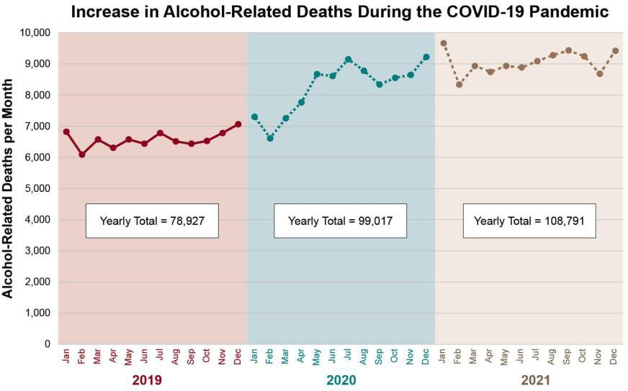

Based on the above chart from the National Institute on Alcohol Abuse and Alcoholism discuss the following:
  - During the pandemic, the number of alcohol rated deaths began to rise. Discuss your thoughts from a social, psychological, or biological perspective on why numbers began to rise during this time. You can include ideas such as job loss, mental health deterioration, etc.
  - Discuss one theory in detail that relates to the use and abuse of alcohol consumption. Provide examples to support your choice.
  - Do you consider alcohol a drug? Should greater control be imposed on the sale of alcohol?

4b. Web link Example: Study on Developmental Theory: https://www.youtube.com/watch?v=ATg4dFa6Oqs

