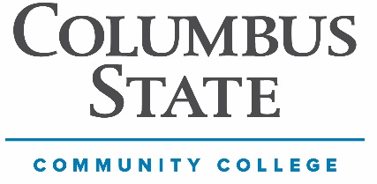
Columbus State Community College

Division: Business, Education, & Technology

Department: Engineering Technologies

COURSE NUMBER: SCM-2994 COURSE TITLE: Supply Chain Management – Current Topics*

INSTRUCTOR: Jeremy Banta CONTACT: See Below

CREDITS: 1.0 - 3.0 CLASS/CONTACT HOURS PER WEEK: 1.0 - 3.0 PREREQUISITES: None

*Class Requires Program Coordinator, Lead Faculty and/or Department Chair Approval

DESCRIPTION OF COURSE: SCM 2994 gives students an opportunity to examine, in detail, special topics of interest in supply chain management (logistics). Topics will vary.

COURSE STUDENT LEARNING OUTCOMES: Varies per Each Class and Student

PROGRAM OUTCOMES
At the completion of this program of study, students must be able to
- Earn a degree and/or certificates in Supply Chain Management
- Continue their education in Supply Chain Management
- Gain employment in Supply Chain Management or related career field

OUTCOMES BASED ASSESSMENT OF STUDENT LEARNING

For this course, students are expected to demonstrate the skills associated with the Institutional Learning Goals (ILG) identified below:

- Varies per Each Class and Student

In class students are assessed on their achievement of these outcomes. Names will not be used when reporting results. Outcomes-based assessment is used to improve instructional planning and design and the quality of student learning throughout the college.

COURSE MATERIALS REQUIRED: None

TEXTBOOK(S), MANUALS, REFERENCES, AND OTHER READINGS: None

GENERAL INSTRUCTIONAL METHODS: Lectures, case studies, discussion, quizzes.

STANDARDS AND METHODS FOR EVALUATION: Case study analysis, quizzes, and classroom participation.

Assignments and Grades Vary Per Class and Student

Total Course Score: 1000 Points

GRADING SCALE
900 to 1000 points (90%-100%): A
800 to 899 points (80%-89%): B
700 to 799 points (70%-79%): C
600 to 699 points (60%-69%): D
599 points and under (0%-59%): F

SPECIAL COURSE REQUIREMENTS: None

ATTENDANCE POLICY: Section Specific – Class Participation will be set by each individual instructor.

COLLEGE SYLLABUS STATEMENTS
Columbus State Community College required College Syllabus Statements on College Policies and Student Support Services can be found at www.cscc.edu/syllabus or on the College website Quick Links “Syllabus Statements”.

WEATHER RELATED DEPARTMENT SPECIFIC POLICY: Covered by College Policy

UNITS OF INSTRUCTION: Varies per Each Class and Student

