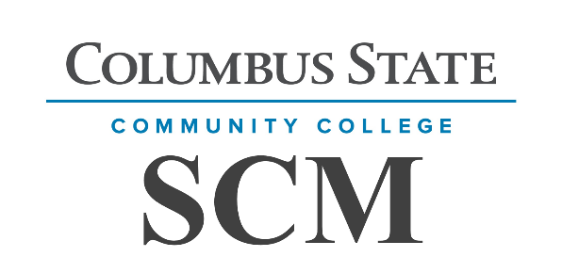
Columbus State Community College
Engineering Technology and Transportation Department Supply Chain Management

COURSE SYLLABUS

COURSE NUMBER: SCM-2250

COURSE TITLE: Import/Export Regulations & Compliance
INSTRUCTOR: CONTACT: See Below

CREDITS: 3 CLASS HOURS PER WEEK: 3 PREREQUISITES: SCM 1100

DESCRIPTION OF COURSE
SCM 2250 discusses – from the perspective of logistical services users, e.g., importers, exporters, and international firms – the history and development of international trade; trade terms; payment terms and methods; currency exchange risks; commercial documents; international insurance; ocean, air, and multi-modal transport; packaging; international logistics infrastructure; international contracts; and Incoterms®

COURSE STUDENT LEARNING OUTCOMES
At the completion of this course of study, students must be able to
- Explain/recognize the risks associated with selection of trade terms;
- Identify the various common international payment terms and compare them from the perspective of risk to both seller and buyer;
- Explain the purpose served by the major commercial documents used in international trade;
- Identify the three alternatives for choosing the currency used in an export or import transaction;
- Explain how the factors of fluctuation and convertibility affect this choice;
- Define the term “infrastructure”

PROGRAM OUTCOMES
At the completion of this program of study, students must be able to
- Earn a degree and/or certificates in Supply Chain Management
- Continue their education in Supply Chain Management
- Gain employment in Supply Chain Management or related career field

COURSE MATERIALS REQUIRED
None

TEXTBOOK(S), MANUALS, REFERENCES, AND OTHER READINGS
International Logistics, the management of international trade operations, 4th Edition, pp. 695, David, Pierre, Cicero Books, Berea, OH 44017, ISBN 13:978-0-9894906-0-3.

GENERAL INSTRUCTIONAL METHODS
Self-study of text; open-book quizzes; final exam; email Q&A with instructor; internet research for written assignments, and periodic optional tours.

STANDARDS AND METHODS FOR EVALUATION
Case study analysis, quizzes, and classroom participation.
Quizzes: 16 Quizzes (2pts/Question) 640 Points
Case Study: 1 Case Study – 90 Points 90 Points
Final: Final – 50 Q’s/5 Pts Each 250 Points
Attendance/Participation: 30 Points

Total Course Requirements: 1000 points maximum GRADING SCALE
900 to 1000 points | (90%-100%): | A
800 to 899 points | (80%-89%): | B
700 to 799 points | (70%-79%): | C
600 to 699 points | (60%-69%): | D
Under 599 points | (0%-59%): | F

ATTENDANCE/PARTICIPATION POLICY
As an online class attendance points are tied to completing all assignments on-time. One point is given for each week that all items are completed on time.

LATE ASSIGNMENT POLICY
Assignments are normally due on Tuesdays by MIDNIGHT. Exceptions will be annotated as needed and communicated separately. Late assignments are accepted, but with a grade penalty:
- day late 90% of the Maximum Grade
- days late 80% of the Maximum Grade
- days late 70% of the Maximum Grade Greater than 3 days No Credit
Exceptions to the late policy are possible to accommodate extenuating circumstances, but must be coordinated and approved by the instructor in advance.

COLLEGE SYLLABUS STATEMENTS
Columbus State Community College required College Syllabus Statements on College Policies and Student Support Services can be found at www.cscc.edu/syllabus or on the College website Quick Links “Syllabus Statements”.

UNITS OF INSTRUCTION
*** See Separately Published “Weekly Assignment Sheet” ***

INSTRUCTOR INFORMATION
My name is Jeremy Banta and I am a full-time instructor at CSCC. For initial contact with a question or problem, I prefer you email me at jbanta1@cscc.edu. I promise to do my best to reply in less than 24 hours. When sending an email, please annotate your class and the assignment/issue in the subject line. Example: SCM 1234 – Quiz #1, Question 3.
If you have a more urgent need, please call my office at 614-287-2559 (leave a message if I don’t answer) or text me at 614-226-2211. If you do text me, please tell me who you are and what class you attend! You are also welcome to stop by my office anytime on the main Columbus campus in Eibling Hall, room 417.
My current office hours are Monday: 9:00 -11:00, Tuesday: 1:00 -3:00, Wednesday: 1:00 -3:00 and
Thursday 10:00 to 12:00 and 2:00 to 2:30.

