Columbus State Community College Business and Industry Department Real Estate Technology

COURSE: Introduction to Property Renovations REAL 2275 Tuesdays 6:00 – 8:50 PM | Spring 2026 Delaware Hall | Room 106-A

CREDITS: 2 CLASS HOURS PER WEEK: 3 PREREQUISITES: None

Instructor: Bryan Savage Oﬃce Telephone: 614-327-4268
E-mail Address: bsavage8@cscc.edu or bsavage@savagerealestate.biz (preferred) CSCC Oﬃce: Delaware Hall (DE)
(by appt only) 550 E Spring St Room 259
Columbus, Ohio 43216

REAL ESTATE PROGRAM COORDINATOR & ADVISOR
Jacqueline Lovelace | DE Room 231 | 614-287-2313 | Email (preferred): jlovelace5@cscc.edu

DESCRIPTION OF COURSE
This course introduces students to a broad overview of architectural styles common in the United States and their historical signiﬁcance, steps one will take to renovate a property (blueprints, architects, working with contractors, etc…) that complies with city code and how to do the work yourself. We will discuss primary is-sues and requirements associated with historical properUes which will include the review of architectural and construcUon styles along with understanding some of the repair issues that may impact the renovaUon of these properUes. We will also review the scope, material and labor investments required for common residen-Ual and commercial renovaUons and you will become familiar with the terms and material used by renovators to accomplish these renovaUons.

COURSE GOALS
To provide working knowledge of how to idenUfy key areas of need for renovaUon and the value that the reno-vaUon will add to the property. Understand architect and the signiﬁcance it has in not only the design and funcUon of the property, but also the land it is on. To provide and idenUfy a scope of work and general costs associated with renovaUng a property.

STUDENT LEARNING OUTCOMES
- IdenUfy architectural styles and future housing trends
- IdenUfy and evaluate basement and foundaUon construcUon present and past
- IdenUfy various framing techniques
- Explain a typical asphalt shingle roof, versus a rubber roof and slate roof

- DisUnguish key concepts of venUlaUon and venUlaUon devices and why they are needed (transoms, cold air returns, radon systems, etc…)
- Describe types of insulaUon and where they should be installed
- Explain basic guXer installaUon and why they are used (standard versus box)
- Describe types of paints and stains (spraying versus brushing [back brushing] versus rolling)
- List basic steps in the drywall process
- Explain and evaluate types of electrical wiring, speaker and cable wires, breakers vs fuse vs nob and tube, exterior electrical devices and future trends, such as solar
- Explain basic plumbing, sepUc systems, sewer systems and drainage (including sump pumps, french
drains, etc…)
- Explain basic HVAC systems including forced air, boiler, heat pumps, split systems, etc…
- Be able to list the permit process and why they are required
- Be able to compare and contrast general contractor bids, including sub-contractors
- Be able to interpret/explain a home inspecUon report and why they are used

GENERAL EDUCATION OUTCOMES
Columbus State Community College's general educaUon outcomes are an integral part of the curriculum and central to the mission of the college. The Columbus State faculty has determined that these outcomes include the following competencies:
- CriUcal Thinking
- EﬀecUve CommunicaUon
- Community and Civic Responsibility
- InformaUon Literacy
- An understanding of key principals and concepts involved in a real estate transaUon

COURSE MATERIALS REQUIRED
Textbook, calculator, computer and internet access.

TEXTBOOK, MANUALS, REFERENCES, AND OTHER READINGS

A Field Guide to American Houses Published by: Knopf
Authored by: Virginia Savage McAlester

An IntroducUon to Building and RenovaUng Houses Published by: Panet PublicaUons
Authored by: Paul Netscher

GENERAL INSTRUCTIONAL METHODS
Text, Lecture, Power Points, videos/YouTube, handouts, class discussion, class projects, problem solving, case studies and acUve class parUcipaUon, homework, reading assignments, quizzes, and exams

BLACKBOARD
Course syllabus, reading assignments, homework assignments, all announcements and emails (CSCC) will be communicated through the “Blackboard System”. All students are responsible to check the Blackboard System regularly for updated informaUon and announcements regarding this class.

ASSESSMENT
Columbus State Community College is commiXed to assessment (measurement) of student achievement of academic outcomes. This process addresses the issues of what you need to learn in your program of study and if you are learning what you need to learn. The assessment program at Columbus State has four speciﬁc and interrelated purposes: (1) to improve student academic achievements; (2) to improve teaching strategies; (3) to document successes and idenUfy opportuniUes for program improvement; (4) to provide evidence for insU-tuUonal eﬀecUveness. In class, students are assessed and graded on their achievement of the outcomes for this course. Students might also be required to parUcipate in broader assessment acUviUes.

METHODS FOR EVALUATION AND GRADING SCALE:
Students are required to demonstrate competency in the following categories and the ﬁnal grade will consist of a leXer grade which coincides with the “Methods For EvaluaUon” (Quizzes, Projects and Exams):
Category | Qty | Points | Total Points
Homework | 5 | 50 | 250
Final Project | 1 | 250 | 500
Mid Term | 1 | 150 | 650
Final Exam | 1 | 200 | 800
Class ParUcipa-Uon | 1 | 200 | 1000
Total Points: 1000 Points

Grade | Range
A= | 900-1000
B= | 800-899
C= | 600-799
D= | 500-699
E= | Below 499 - Failed

IMPORTANT DATES
Spring Break March 16-23, 2026

FINANCIAL AID ATTENDANCE REPORTING
Columbus State is required by federal law to verify the enrollment of students who parUcipate in Federal Title IV student aid programs and/or who receive educaUonal beneﬁts through the Department of Veterans Aﬀairs. It is the responsibility of the College to idenUfy students who do not commence aXendance or who stop aXen-dance in any course for which they are registered and paid. Non-aXendance is reported quarterly by each in-structor, and results in a student being administraUvely withdrawn from the class secUon. Please contact the Financial Aid Oﬃce for informaUon regarding the impact of course withdrawals on ﬁnancial aid eligibility.

STUDENT CODE OF CONDUCT
As an enrolled student at Columbus State Community College, you have agreed to abide by the Student Code of Conduct as outlined in the Student Handbook. You should familiarize yourself with the student code. Columbus State Community College expects you to exhibit high standards of academic integrity, respect and responsibility. Any conﬁrmed incidence of misconduct, including plagiarism and other forms of cheaUng, will be treated seriously and in accordance with College Policy and Procedure 7-10.

AMERICANS WITH DISABILITIES ACT (ADA) POLICY
It is Columbus State policy to provide reasonable accommodaUons to students with documented disabiliUes. If you would like to request such accommodaUons because of physical, mental or learning disability, please con-tact the Department of Disability Services, 101 Eibling Hall, 614.287.2570 (V/TTY). Delaware Campus students may also contact an advisor in the Student Services Center, ﬁrst ﬂoor Moeller Hall, 740.203.8000. Ask for Del-aware Campus advising, or www.cscc.edu/delaware, for assistance.

INCLEMENT WEATHER OR OTHER EMERGENCIES
In the event of severe weather or other emergencies that could force the college to close or to cancel classes, such informaUon will be broadcast on radio staUons, television staUons, campus website or by text alert. Stu-dents who reside in areas that fall under a Level III emergency should not aXempt to drive to the college even if the college remains open.
- Assignments due on a day the College is closed will be due the next scheduled class period.
- If an examinaUon is scheduled for a day the campus is closed, the examinaUon will be given on the next scheduled class day.
- Students who miss a class because of weather-related problems will be held responsible for reading
and other assignments as indicated in the syllabus. Remember….it is the student’s responsibility to keep up with reading and other assignments when a scheduled class does not meet, whatever the rea-son.
- In the event the College is forced to close during ﬁnal examinaUon week, scheduled exams will be
rescheduled and students will be noUﬁed of the new Ume and date using their Columbus State e-mail address and an announcement will be placed on Blackboard.
- Students are responsible for checking their assigned email.
- Students lacking access to email at home must prearrange with the instructor an alternate method of being informed.

CODE OF CONDUCT IN THE CLASSROOM:
- Read syllabus and understand content.

Be on ?me to class; late arrival(s) may result in deduc?on of points.
- NO SMOKING OR TOBACCO PRODUCTS in building and classroom.

- Please turn oﬀ sound for all phones and pagers.
- You can bring food into class. However, you are able to have a beverage (water, soda, or coﬀee) and snack in class. You must clean up aver class or this privilege may be revoke for all students.
- No admiXance to class on exam day (s) aver exam has started. If you leave the classroom during the test/exam you will not be permiXed to return and complete the test/exam.
- No children or guests in class.
- All homework and grades will be posted on Blackboard.
- You must complete all exams.

ATTENDANCE

“Columbus State is required by federal law to verify the enrollment of students who par?cipate in Federal Title IV student aid programs and/or who receive educa?onal beneﬁts through the Department of Veteran’s Aﬀairs. It is the responsibility of the College to iden?fy students who do not commence amendance or who stop amendance in any course for which they are registered and paid. Non-amendance is reported quarterly by each instructor, and results in student being administra?vely withdrawn from the class sec?on. Please contact the Financial Aid Oﬃce for informa?on regarding the impact of course withdrawals on ﬁnancial aid eligibility.”
It is understood that from Ume to Ume a student may have a conﬂict with a scheduled class session. However, it will be up to the student to decide what is more important: this is not the instructor’s decision or that of the Real Estate Department. If a student elects not to aXend class, he/she will be held liable for missed class mate-rial/assignments and might not be allowed to make up any missed work including, but not limited to, quizzes, tests, and exams.

Students should contact the instructor as soon as possible aver an emergency situaUon that prevents the stu-dent from contacUng the instructor in advance. If you have any quesUons on this policy, please ask your in-structor for clariﬁcaUon the ﬁrst night of class.

The professor reserves the right to modify/change exam days and Ume with proper noUce to all students regis-tered for this class. Proper noUce of changes will be posted on Blackboard. It will be the student responsibility to check Blackboard on a daily basis.

PERSONAL NOTE
The real estate business is centered upon people. I expect professional behavior from everyone at all Umes. I hold myself to that same standard. We can have fun, but a business-like and courteous classroom is an essen-Ual backdrop to the signiﬁcant learning you will achieve in this class.
If you need to meet with me, please contact me so we can arrange a Ume that will be convenient for you. It is best that you text or used my preferred email to make an appointment.
It is “my goal” to help each student when the need arises. If you are in need of addiUonal assistance with the lesson plan or wish to discuss this course, please inform me. I am willing to arrange a schedule Ume to talk with you and discuss your concern(s); if this is not possible for you, then you may address your concerns in an email. Please remember, you must make the eﬀort to ask.

STUDENT PROFILE
Please complete this informaUon form and return to instructor on or before the 2nd week of class. This will en-able the instructor to contact you if necessary, and to learn more about your interests and experience. By sign-ing this form you are staUng that you have read and understand the class syllabus.

Class:

Name: (Please Print/Type)
Address: City/State/Zip:
Home Phone: Work Phone: Fax:

E-mail Address:

What is your major course of studies at Columbus State Community College:

Your educaUonal goals:

What other real estate classes have or are you taking currently:

Are you planning on becoming a real estate professional:

Are you planning on taking the state real estate licensing exam:

Please take Ume to tell me something about yourself; this will help me to know you:

Employer:

Job Title: Part-Ume: Full-Ume:

Student has received and read a copy of the syllabus. In addiUon, the instructor has explained the syllabus in detail regarding the requirement from each student in this class. Student further agrees and understands the aXendance policy, late assignment policy and that there is no make-up on quizzes and exams. By signing this you have agreed to abide by the content of this syllabus.

STUDENT SIGNATURE: DATE:

CLASS SCHEDULE – Autumn 2026 INTRODUCTION TO PROPERTY RENOVATIONS [REAL 2275]

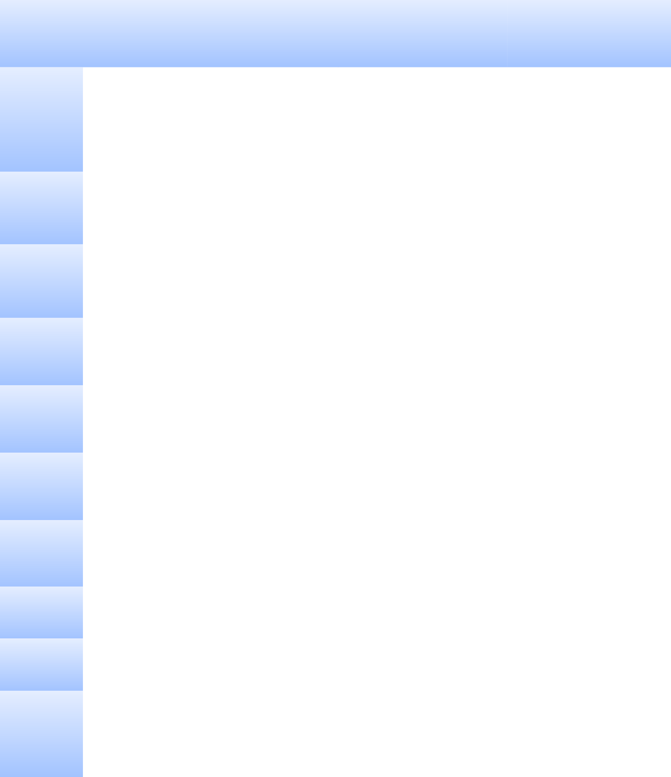  WEEK | UNIT OF INSTRUCTION | ADDITIONAL NOTES | READING ASSIGNMENTS
Week 1-2 | Looking at American Houses, Folk Houses | Homework #1, with presenta- | Pages 3-156
 |  | tion in Week 2
January 20
and January
27
Week 3  February 3 | Colonial Houses, Romantic Houses and Victori-an Houses |  | Pages 157-397
Week 4  February 10 | Eclectic Houses: English & Anglo-American, French Period, Mediterranian & Spanish | Homework Assignment #2 | Pages 398-543
Week 5  February 17 | Eclectic Houses: English & Anglo-American, French Period, Mediterranian & Spanish | Homework Assignment #2-Presentation | Pages 398-543
Week 6  February 24 | Modern Houses: Early Modern, Bankers Mod-ern, Mainstream Modern |  | Pages 549-673
Week 7  March 3 | Modern Houses: Early Modern, Bankers Mod-ern, Mainstream Modern |  | Pages 549-673
Week 8  March 10 | Styled Houses since 1935 Give Exam #1: All Chapters | Mid-term Exam | Weeks 1-8
Spring Break | March 16 -March 23
Week 9  March 17 | Home Inspection Report,
Week 10  March 24 | An Introduction to Building and Renovating Houses Chapters 1-3 | Homework Assignment #3-Home Inspection presentation

  Week 11  March 31 | An Introduction to Building and Renovating Houses Chapters 1-3
Week 12  April 7 | An Introduction to Building and Renovating Houses Chapters 4-6 | Homework Assignment #4
Week 13  April 14 | An Introduction to Building and Renovating Houses Chapters 7-8
Week 14  April 21 | An Introduction to Building and Renovating Houses Chapters 9-10 | Homework Assignment #5
Week 15  April 28 | An Introduction to Building and Renovating Houses Chapters 11-12 | Review and Exam Overview
Week 16  May 5 | Final Exam and Final Propjects
Week 17  May 12 Last week of class | Final Project Due: Class Discussion | The final project consists of each student identifying a property for renovation, devel-op a scope of work with costs for each line item

