
Business Programs Marketing

COURSE NUMBER: COURSE TITLE:
MKTG 1230
Customer Service and Sales

LEAD FACULTY: CONTACT: cscc.edu

CREDITS:
CLASS HOURS PER WEEK: PREREQUISITES:
3.0
3 hours None

DESCRIPTION OF COURSE
MKTG 1230 introduces the sales process and the key role that sales activities play in any consumer or commercial business endeavor. The course deals with the basic components of selling including understanding customer psychology and building customer relationships. This course also emphasizes the important issues facing customer service providers and customer service managers in business. Special emphasis is placed on the mastery of specific skills and analyzing customer attitudes and behaviors to determine the tasks required to deliver excellent customer service.

COURSE STUDENT LEARNING OUTCOMES
The course outcomes for Customer Service and Sales include the following competencies:
- Practical understanding of the role of customer service and sales within marketing
- Working knowledge and application of sales terminology, concepts, activities, and strategies.
- Understanding of sales functions within the organization and external environments and sales contributions to organizational attainment of goals and objectives
- Quantitative and qualitative analytical skills through the application of sales concepts, theories, and tools for setting strategies and solving sales problems
- Skills in creative and critical thinking, written and oral communication, and ethical reasoning

PROGRAM OUTCOMES
The program provides the skills graduates need to enter careers in sales, customer service, advertising, and small-business promotion. The Marketing program provides a strong foundation in fundamental marketing concepts and principles. The advanced courses provide the opportunity for studying topics of particular interest to the student in such areas as consumer behavior, digital marketing, and sales techniques. Courses incorporate realistic projects, case analyses, simulations, presentations, and teamwork. All of the courses in the Marketing program provide students with high-quality instruction in a small classroom setting or online.

OUTCOMES-BASED ASSESSMENT OF STUDENT LEARNING
For this course, students are expected to demonstrate the skills associated with the Institutional Learning Goals (ILG) identified below:

- Critical Thinking
- Ethical Reasoning
- Quantitative Skills
- Technological Competence
- Communication Competence
- Cultural and Social Awareness
- Professional & Life Skills

Students are assessed on their achievement of these outcomes. Names will not be used when reporting results. Outcomes-based assessment is used to improve instructional planning and design and the quality of student learning throughout the college.

COURSE MATERIALS REQUIRED
- You must have access to a computer equipped with Microsoft Office (or equivalent word processing program like Google Docs) and reliable Internet access from a browser that is compatible with Blackboard and Connect. To find out if your technology meets these requirements, please review this webpage on Technical Requirements¹ for classes at CSCC.
- You must have an access code for Connect. This is included with the purchase of a new book as well as in Instant Access courses. If you purchase a used book, then you will need to purchase the code from McGraw Hill. The Columbus State Book Store has the best price for this book. Grades for homework and quizzes created during Connect’s free “trial period” are not retained beyond the trial period unless the code is purchased. These trial period grades will not be used in the course grade computation if the code is not purchased.

TEXTBOOK(S), MANUALS, REFERENCES, AND OTHER READINGS

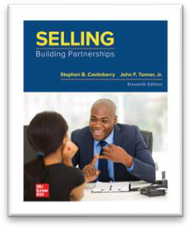 | Selling: Building Partnerships (11th edition)² by Stephen Castleberry and John Tanner  All sections of this course are designated as “Instant Access.” In these sections, a digital copy of the textbook is included in your course fees and you do not need to purchase a separate book. If you’d rather have a physical book, you may opt-out of this program. You can find out more information about “Instant Access” and the opt-out procedure on the CSCC Bookstore website³.
Customer Service Management by Steven R. Van Hook, PhD

This textbook is provided to students as an Open Educational Resource at no cost. It is provided via the appropriate Blackboard modules.

This work is licensed under a Creative Commons Attribution 4.0 License.
All other reading material is included within Blackboard or linked to from within Blackboard to third-party sites.

GENERAL INSTRUCTIONAL METHODS
This course utilizes the required textbook in conjunction with frequent, low-stakes adaptive study tools and questions, class discussions (or online discussion boards), multimedia presentations, and individual assignments. It is taught in lecture, blended, and online formats.

STANDARDS AND METHODS FOR EVALUATION

Simulations
Simulations allow students to try out concepts in a guided practical application setting.

Quantity - 2 | Points Each - 15 | Approximate Time Needed - 1 hour

¹ https://www.cscc.edu/academics/online-learning/technical-requirements.shtml
²https://www.mheducation.com/highered/product/1260682951.html
³ https://www.cscc.edu/services/bookstore/affordability-bookstore.shtml

each

Guided Readings
Each module is coupled with a corresponding guided reading assignment. These low-stakes assignments help students recognize concepts they may need to take more time on.

Quantity - 7 | Points Each - 10 | Approximate Time Needed - 1 hour - 2  hours each  -

Concept Checks
After completing each module’s guided reading, students have the opportunity to make sure they understand the
concepts found in that module.

Quantity - 10 | Points Each - 20 | Approximate Time Needed - 30 -60  minutes each  -

Discussion Boards
Class participation points will be awarded at the discretion of your instructor and for active participation and contribution to class discussions. These are not attendance only points. For online sections, there will be discussion board assignments. Your responses should be respectful and substantive to receive credit.

Quantity - 10 | Points Each - 20 | Approximate Time Needed - 30  minutes - 60 minutes each  -

• Application Exercises
Students will be required to complete five application exercises that put into practice the theories they have learned. These exercises get progressively more intensive to give students the opportunity to ramp up their practical application. Rubrics and general comments will be provided with the grade and detailed feedback will be provided upon request.

Quantity - 5 | Points Each - 100 | Approximate Time Needed - 3 - 6  hours each  -

Certification (Extra Credit)
Students will have the opportunity to earn extra credit while earning a certification they can put on their resume.

Quantity - 1 | Points Each - 50 | Approximate Time Needed - 2.5 hours

GRADING SCALE
Course grading is based on the total points earned of the total points possible (total points earned divided by total points possible equals percentage earned).
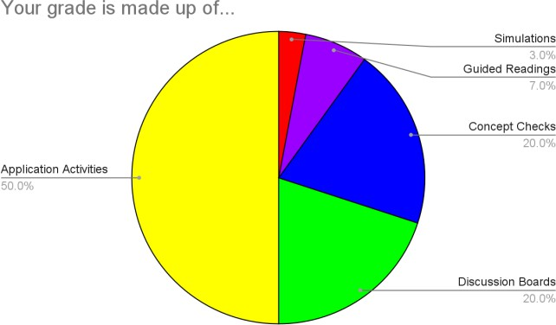

Assessment Type | Quantity | Points Each | Total | 1000
Simulations | 2 | 15 | 30
Guided Readings | 7 | 10 | 70
Concept Checks | 10 | 20 | 200
Discussion Boards | 10 | 20 | 200
Application Activities | 5 | 100 | 500

Extra Credit is available for 50 additional points.

Letter | Percentage | Point Range
A | 90 - 105% | 900 - 1050
B | 80 - 89% | 800 - 899
C | 70 - 79% | 700 - 799
D | 60 - 69% | 600 - 699
E | 59 - 0% | 0 - 599

SPECIAL COURSE REQUIREMENTS

Late Assignment Policy
All late assignments, no matter how close to their deadline, will receive a score of zero. The time the submission as recorded as received by the Blackboard internal clock is the arbiter for this deadline, regardless of when you logged on, when you clicked submit, when you last saved the file, what time your computer said it was, etc. Technology-related issues such as Internet access, submitting the wrong file, or problems with personal computers will not excuse a late submission; plan ahead and finish your work with time left to submit it. The student assumes the risk of last-minute electronic submission.

Communication with Instructor
Your instructor may periodically check email during evening and weekend hours, but this may not be the standard. If you have questions or concerns over the weekend, you may not receive a response until the next business day. Please email from the “Email Instructor” link in the left-hand navigation in Blackboard or include the class name and section number in your email.

Student Responsibility
One of the tenets of this course is personal responsibility. This means that you play an active role in your education and as a student in this class. Therefore, it is your responsibility to make sure you know the policies listed on this syllabus, the policies of the university as they relate to this course, and all assignment deadlines. Please note that you are also responsible for making sure all of your work is uploaded correctly and completely to Blackboard by the deadline. While your instructor will try to assist you as best as they can, if you have any questions about technical issues, your best course of action is to first contact CSCC Technical Support⁴.

Plagiarism
All written work submitted in this course, except for acknowledged quotations, is to be expressed in your own words. Work copied from a book, from another student’s paper, or from any other source is not acceptable. The submission of such copied work will render the offending student subject to an E grade for the work in question and will also make him/her liable for referral to the Office of Student Conduct for further disciplinary action.
Moderate quotation for illustrative ends is often advantageous. Such passages must be placed within quotation marks or otherwise identified. Moreover, if reliance is placed upon a particular work for ideas, the acknowledgment must be made. The instructor will be glad to answer questions as to the proper use of footnotes and citations for the identification of sources.

ATTENDANCE POLICY
Attendance will be measured by the successful, timely completion of course assignments. Simply "showing up" or logging into Blackboard will not count as attendance.

MATURE CONTENT WARNING
Our classroom provides an open space for the critical and civil exchange of ideas. Some readings and other content in this course will include topics that some students may find offensive and/or traumatizing. I’ll aim to forewarn students about potentially disturbing content, and I ask all students to help to create an atmosphere of mutual respect and sensitivity⁵.

STANDARD SYLLABUS STATEMENT: STUDENT RESOURCES, RIGHTS, AND RESPONSIBILITIES
https://www.cscc.edu/academics/syllabus.shtml

UNITS OF INSTRUCTION
See Course Calendar.

⁴ https://www.cscc.edu/services/itsc/
⁵ "Trigger Warnings", University of Waterloo Centre for Teaching Excellence is licensed under CC BY-NC 4.0

