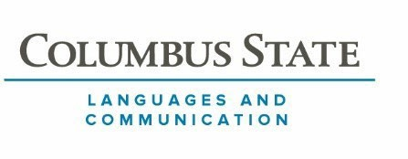
ARTS AND SCIENCES DIVISION
Language and Communication

COURSE NUMBER: Japanese 1101 COURSE TITLE: Beginning Japanese I

CREDITS: 4

PRE-REQUISITES: Placement into ENGL 1100

COURSE DESCRIPTION:
A common objective of Japanese 1101 and all the Japanese courses that follow is for students to feel comfortable interacting in Japanese with natives of Japanese, whether in speech or in writing. To achieve this objective, students need readiness and accuracy in word choice, grammar, pronunciation, writing, and socio-cultural strategies. These skills make effective communication possible. Most class hours are therefore devoted to using Japanese common culturally Japanese situations, by means of spoken Japanese at first, and then by means of spoken and written Japanese. To facilitate this, in-class work and most out-of-class assignments focus on the preview, analysis, and rehearsal of communicative skills, their mechanics and meanings. The student’s job is to study the audio models and, when available, video materials and to rehearse them thoroughly, so students can recognize and produce them readily when given the opportunity to
do so in class.

COURSE LEARNING OUTCOMES:
Begin developing a repertoire of skills for fluent interactions in Japanese.

More specifically, students will:
- Hear and produce the sounds of Japanese accurately;
- Master basic interaction skills, including greeting, inquiring, inviting, asserting, confirming, checking for agreement, evaluating, apologizing, and identifying;
- Experience interactions in such settings as office, school, shops, restaurants, and home;
- Begin to incorporate cultural factors that are reflected in language use, such as hierarchy, familiarity, and group concepts;
- Gain skills for interaction involving requests and expressions of possibilities;

- Understand the basic features of the written language;
- Read items written in Hiragana and katakana;

OTM LEARNING OUTCOMES: Not Applicable

TAG LEARNING OUTCOMES: Not Applicable

COURSE MATERIALS:

- NihonGO NOW! Performing Japanese Culture – Level 1 Field Test Edition (V.19-8) by Mari Noda, Patricia J. Wetzel, Ginger Marcus, Stephen D. Luft, Shinsuke Tsuchiya, Masayuki Itomitsu

- NihonGO NOW! Performing Japanese Culture – Level 1 Field Test Edition, Activity Book (v.19-8) by Mari Noda, Patricia J. Wetzel, Ginger Marcus, Stephen
D. Luft, Shinsuke Tsuchiya, Masayuki Itomitsu

STANDARDS AND METHODS FOR EVALUATION:

Students will be evaluated on the following assignments:
General performance as reflected in your daily grade …50% Homework/quizzes …10%
Examination …20% Oral Interviews …20%

GRADING SCALE:
A = 90% - 100%
B = 80% - 89%
C = 75% - 79%
D = 60% - 74%
E = 59 and below

*Students must have a final grade of 75% or higher to continue to Japanese 1102.
SPECIAL COURSE REQUIREMENTS (delete if not applicable):

COLLEGE SYLLABUS STATEMENTS

Columbus State Community College required College Syllabus Statements on College Policies and Student Support Services can be found at www.cscc.edu/syllabus or on the College website Quick Links “Syllabus Statements”.

UNITS OF INSTRUCTION, OUTCOMES AND ASSESSMENT ALIGNMENT (choose
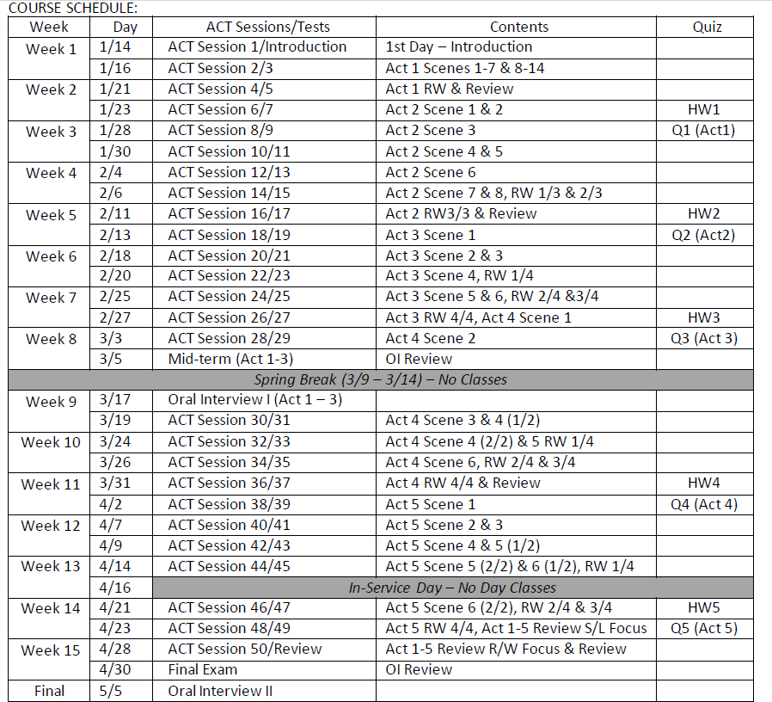
Sample A, Sample B or another method that clearly shows the units of instruction, alignment of learning outcomes and assessment methods)

