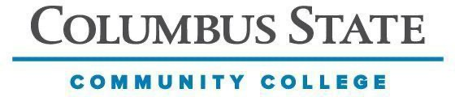
Applied Sciences and Human Services Department
Interpreter Education Program
IEP 1294

Instructor:
Email:
Credit(s): varies
Class Hours: varies
Prerequisites: Admittance or completion of the interpreting program

Additional Points of Contact
If you have any questions or concerns regarding this course, please feel free to reach out to one of the following:
Lead Instructor:
IEP Program Coordinators:
Department Chair:

DESCRIPTION OF COURSE
This course is offered for interpreters who are employed, or are pre-practice interpreters, interested in exploring or developing an issue or skill related to ASL. This course is repeatable up to six hours and fulfills the Technical Elective requirement.

COURSE STUDENT LEARNING OUTCOMES
Varies depending on the topic.

PROGRAM OUTCOMES
Varies depending on the topic.

OUTCOMES BASED ASSESSMENT OF STUDENT LEARNING
Varies depending on the topic.

COURSE MATERIALS REQUIRED
Varies depending on the topic.

GENERAL INSTRUCTIONAL METHODS
Varies depending on the topic.

STANDARDS AND METHODS FOR EVALUATION
Columbus State Community College is committed to assessment (measurement) of student achievement of academic outcomes. This process addresses the issues of what you need to learn in your program of study and if you are learning what you need to learn. The assessment program at Columbus State has four specific and interrelated purposes: (1) to improve student academic achievements; (2) to improve teaching strategies; (3) to document successes and identify opportunities for program improvement; (4) to provide evidence for institutional effectiveness. In class you are assessed and graded on your achievement of the outcomes for this course. You may also be required to participate in broader assessment activities.

GRADING SCALE
100 – 90% = A, 89 – 80% = B, 79 – 70% = C, 69 – 60% = D, 59% and below = E
If a student earns a D or an E for the course, the course can be repeated when offered again.

SYLLABUS STATEMENTS
https://www.cscc.edu/academics/syllabus.shtml

