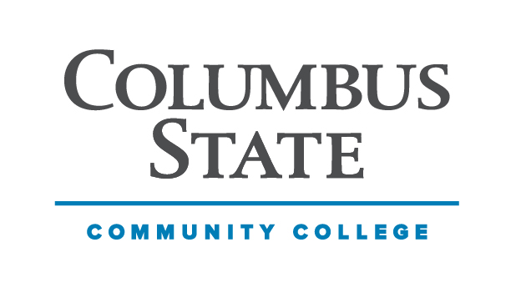
Columbus State Community College
SES/HOSP Department
Health & Human Services Division

COURSE: HOSP2272
COURSE TITLE: Event Management
INSTRUCTOR: CONTACT:
CREDITS: 3 CLASS HOURS PER WEEK: 2 Lecture and 2 Lab PREREQUISITES: None

DESCRIPTION OF COURSE
This course will describe how event managers design, plan, market, and stage an event of any size. The course will describe the managing of staff and how to handle staffing problems. The course will describe the safety requirements that ensure staff and attendees' safety. This course will also describe the legal compliance, risk management, financial control, and evaluations of the success of the event.

STUDENT LEARNING OUTCOMES (SLO)
Upon successful completion of this course the student with a thorough understanding of event management and meeting planning industry.

- Plan several events using the MBECS - Meeting and Business Events Competency Standards
- Identify meeting goals, stakeholders, and types of events.
- Create a comprehensive budget for financial management of an event.
- List and describe legal compliance and contractual obligations associated with the industry.
- Design the elements necessary for planning, managing, marketing and staging events.
- Explain the planning needs using the food and beverage categories.
- Classify the leading organizations and supporting organizations in the meeting and event
planning industry.

PROGRAM LEARNING OUTCOMES
1. Identify and apply the knowledge and skills necessary for hospitality and tourism
Operations.
2. Develop and integrate a core set of business skills necessary to successfully operate a
hospitality and tourism organization.
3. Demonstrate competence in the communication skills necessary for hospitality and
tourism management.
4. Formulate business decisions in hospitality and tourism management.
5. Evaluate leadership principles necessary in the diverse and global hospitality and tourism industry.

INSTITUTIONAL LEARNING GOALS
Columbus State Community College's Institutional Learning Goals are an integral part of the curriculum and central to the mission of the college. The faculty at Columbus State has identified the following institutional learning goals:
- Critical Thinking
- Ethical Reasoning
- Quantitative Skills
- Communication Competency
- Cultural & Social Awareness
- Professional & Life Skills

COURSE MATERIALS REQUIRED

TEXTBOOK, MANUALS, REFERENCES, AND OTHER READINGS
Fenich, G.G. Meeting, Expositions, Events, and Conventions: An Introduction to the Industry. 4th Edition. Prentice Hall; Upper Saddle, NJ. ISBN: 9780133815245

GENERAL INSTRUCTIONAL METHODS
- Lecture and Discussion
- Homework Assignments
- Video Links
- Case Studies - Discussions
- Exams
- Event Design and Projects

ASSESSMENT
Columbus State Community College is committed to assessment (measurement) of student achievement of academic outcomes. This process addresses the issues of what you need to learn in your program of study and if you are learning what you need to learn. The assessment program at Columbus State has four specific and interrelated purposes: (1) to improve student academic achievements; (2) to improve teaching strategies; (3) to document successes and identify opportunities for program improvement; (4) to provide evidence for institutional effectiveness. In class you are assessed and graded on your achievement of the outcomes for this course. You may also be required to participate in broader assessment activities.

UNITS of INSTRUCTION
I. Introduction to Meetings, Expositions, Events & Conventions.
II. Meetings and Conferences
III. Operations and Service Contractors.
IV. Legal Issues in the MEEC Industry.
V. Food & Beverage in MEEC.
VI. Technology and the Meeting Professional.
VII. Destination Management Organizations (DMO).
STANDARDS AND METHODS FOR EVALUATION

8 Attendance / Participation 200 Points (25 ea.)
2 Midterm Exams 300 (150 ea.)
6 Homework Assignments 150 (25 ea.)
Meeting Plan 25 Points
Conference Plan 75 Points
Social Event Plan 100 Points
Convention Plan 150 Points
TOTAL 1000 Points

Grading Scale:
1000-900 A 90%
899-800 B 80%
799-700 C 70%
699-600 D 60%
Below 599 E

ATTENDANCE and ASSIGNMENT POLICY

Attendance is based on discussion and assignments completed and submitted, not just logging in to check weekly posting by instructor on Blackboard.

Students are required to purchase the textbook. The textbook must be purchased by the 2nd class meeting. The chapters covered in class should have been read prior to week of class meeting.

Assignments need to be submitted through Blackboard
Do not email me assignments. They will not be graded.

The class will utilize the textbook. Assignments are due ____________ as indicated on calendar and assignment heading on Blackboard. No late assignments will be collected. No credit will be issued for exams not taken. Grades may be monitored on Blackboard. See GRADE CENTER TAB

COLLEGE SYLLABUS STATEMENTS
Columbus State Community College required College Syllabus Statements on College Policies and Student Support Services can be found at www.cscc.edu/syllabus or on the College website Quick Links “Syllabus Statements”.

Course Learning Outcomes | Teaching and Learning Activities | Method of Assessment | Program Learning Outcomes Aligned with Student Learning Outcomes
Plan several events using the MBECS - Meeting and Business Events Competency Standards | Lecture and in-class discussion and class activity. | Class Participation Graded Assignment | SLO# 1, PLO #2, 3, 4, 5
Identify meeting goals, stakeholders, and types of events. | Review chapters, web pages and accompanying handouts. | Graded Assignment | SLO#2, PLO #1, 2
Create a comprehensive budget for financial management of an event. | In-class discussion. Review applicable web pages and videos. | Class Participation Graded Assignment | SLO #3, PLO #1, 2, 3, 4
List and describe legal compliance and contractual obligations associated with the industry. | Review web pages and accompanying handouts. | Exam | SLO #4 PLO #2, 3
Design the elements necessary for planning, managing, marketing and staging events. | Review web pages and accompanying handouts. | Class Participation Graded Assignment | SLO #5, PLO #1, 2, 3, 4
Explain the planning needs using the food and beverage categories. | Lecture and in-class discussion and assignment | Class/Group Discussion  Project presentation | SLO #6, PLO #3, 5
Classify the leading organizations and supporting organizations in the meeting and event planning industry. | Review webpage links and accompanying handouts. | Graded Discussion Assignment  Exam | SLO #7, PLO #1, 3, 4

