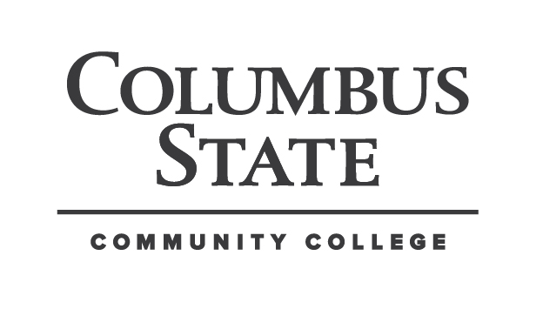

COLUMBUS STATE COMMUNITY COLLEGE
Hospitality Sales & Marketing - HOSP2246

Credit hours: 2
Contact hours: 3

Instructor:
Office:
Office hours:
Phone:
Help Desk:
Class hours:
E-mail address:

Assignment Calendar: There is a separate 8 WEEK assignment calendar for this course. To access and print the weekly calendar go to the Syllabus Tab in Blackboard.

Course Materials:
Required Text: Kotler, P., Bowen, J.T., Makens, J.C., Marketing for Hospitality and Tourism,
Pearson Education, Prentice Hall, New Jersey, 2014, Sixth Edition.

Course Description:
This course provides students with an overview of the marketing function associated with business organizations. This course will focus on the fundamental elements of the services marketing mix which includes the product, promotion, price and place (distribution).
An extension of the traditional marketing mix known as the Extended Marketing Mix, includes People, Process, and Physical Evidence will be discussed.
The concepts of effective marketing, total quality management, relationship marketing, and
competitive strategy are explored in this course. Students will be presented with the basic
knowledge and skills necessary to work within the marketing plan of a hospitality or tourism
organization.
Covers the basic knowledge and skills necessary to develop, implement and evaluate strategic marketing plans for food service, lodging properties and tourism services.

Goals of Course:
Upon successful completion of the course, the student will be able to:
• Describe all aspects of the marketing process.
• Define each term associated with specific marketing concepts.
• Design and illustrate the importance of promotional plan.

General Education Outcomes:
General education at Columbus State Community College provides students with a well‐rounded
educational experience that develops critical thinking skills and a broader knowledge of the larger world around them.
Through a variety of academic disciplines, students develop and refine intellectual virtues like curiosity, open‐mindedness, and analytical judgment. Students also explore ideas, concepts, values, beliefs, social institutions, and cultural experiences that build a basis for civic virtues like public mindedness and an appreciation of the varieties of human existence.

- Critical Thinking
- Ethical Reasoning
- Technological Competence
- Communication Competence
- Cultural & Social Awareness
- Professional & Life Skills

Course Objectives: Student to be able to:

  - Recite various marketing principles from course content.
  - Classify the behaviors of hospitality consumers.
  - Identify criteria of effective segmentation and positioning.
  - Design a marketing plan, based on given criteria
  - Identify importance of developing new products and services.
  - List details of a marketing plan using the promotional mix.
  - Explain the social and ethical criticism of advertising.
  - Create Social Media plan, within a marketing plan.

Course Units:

Unit 1 - Understanding the Hospitality and Tourism Marketing Process

Unit 2 - Developing the Hospitality and Tourism Marketing Opportunities and Strategies.

Unit 3 - Developing the Hospitality and Tourism Marketing Mix

Unit 4 - Managing Hospitality Tourism and Marketing

Instructional Methods:

- Textbook and Internet Reading
- Homework Assignments
- Video Links
- Case Studies
- Exams
- Project

Methods & Standards of Evaluation:

2 Midterm exams 300 (150 ea.)
6 Homework Assignments 300 (50 ea.)
4 Discussions (Attendance) 200 (50 ea.)
Marketing Project 200
1000 points

Grading Scale:

1000-900 A 90%
889-800 B 80%
799-700 C 70%
699-600 D 60%
Below 599 E

*Weekly calendar can be viewed and printed from Blackboard under “Course Information”

* Feedback to your questions will be answered within 24 hours Mon. – Fri.
I will make every effort to answer a question sent on Sat. or Sun. by 5pm Sunday.

Assignments are to be turned in on the day and time they are due.
LATE HOMEWORK ASSIGNMENTS WILL NOT BE ACCEPTED or GRADED
DO NOT email me your assignment.
There are no makeup exams unless arrangements are made with the instructor.

ATTENDANCE POLICY and PARTICIPATION
Students are required to purchase the textbook by the end of Week 1. Assignments are due by 11pm on Monday as indicated on calendar and assignment heading on Blackboard. Grades may be monitored on Blackboard.
Class participation will be evaluated based on the completion of on-line or in-class exercises, responses to instructor’s questions and participation in discussions. Logging into Blackboard, alone will not qualify for class participation points.

ASSIGNMENTS, DISCUSSIONS and EXAMS
All assignments will be posted on Blackboard under the ASSIGNMENTS TAB and are due by 10am on Tuesday following week assigned. Assignments must be uploaded to Blackboard as indicated.

Assignments will be posted under the tab “Assignments” tab and Exams under “Tests/Exams” on Blackboard. An announcement and/or email will alert you to the details.

Exams are taken online. You do not need to go to the testing center.

Please check your student email daily. All inquiries sent to: gfriend1@cscc.edu through Blackboard.

COLLEGE SYLLABUS STATEMENTS
Columbus State Community College required College Syllabus Statements on College Policies and Student Support Services can be found at www.cscc.edu/syllabus or on the College website Quick Links.
