
Columbus State Community College Business Programs Department FMGT Technology
Course Syllabus

COURSE: Finance 2242 – International Finance CREDITS: 3.0 CLASS HOURS PER WEEK: 3.0
PREREQUISITES: FMGT 1101 (Recommended: FMGT 2201)
Instructor: Chad Wood Email: cwood49@cscc.edu

DESCRIPTION OF COURSE
This course covers the multinational firm, globalization, balance of payments, market for foreign exchange, international monetary system, and global capital markets. Also covered is the study of global debt and equity markets to optimize a firm’s financial structure while minimizing foreign exchange exposure.

GOALS
My goal in this class is for you to succeed. I am available for questions during my office hours at a minimum, but am flexible to your schedule as well. Many students contact me for questions about course content, but feel free to contact me with other issues as well. I am not a counselor, but do know how to help you find financial, mental health, or other resources during these challenging times.
Any student experiencing food, housing, or other basic needs challenges is urged to contact a Peer Advocate in Student Advocacy by emailing peeradvocates@cscc.edu or calling 614-287-5192; they can connect you to resources for support. In addition, if you are comfortable doing so, please notify me so I can provide information and support as well. There is also a new resource to help online students. Check it out at cscc.edu/online101.
Maybe you don’t know: The Mid-Ohio Market at CState is open for curb-side service Mondays and Thursdays from 11am-4pm and Wednesdays 3-7pm. (These hours can shift. See here for updates: https://www.cscc.edu/services/mid-ohio-market/index.shtml). To be eligible, your income must be at or below 200% of the federal poverty level. For one person, that’s about $25,000/year or $2100/month for one person. As income may vary weekly and/or monthly for many people at this time, this may be a temporary need that CSCC can help with. Income verification information is not required. You must bring a picture ID.

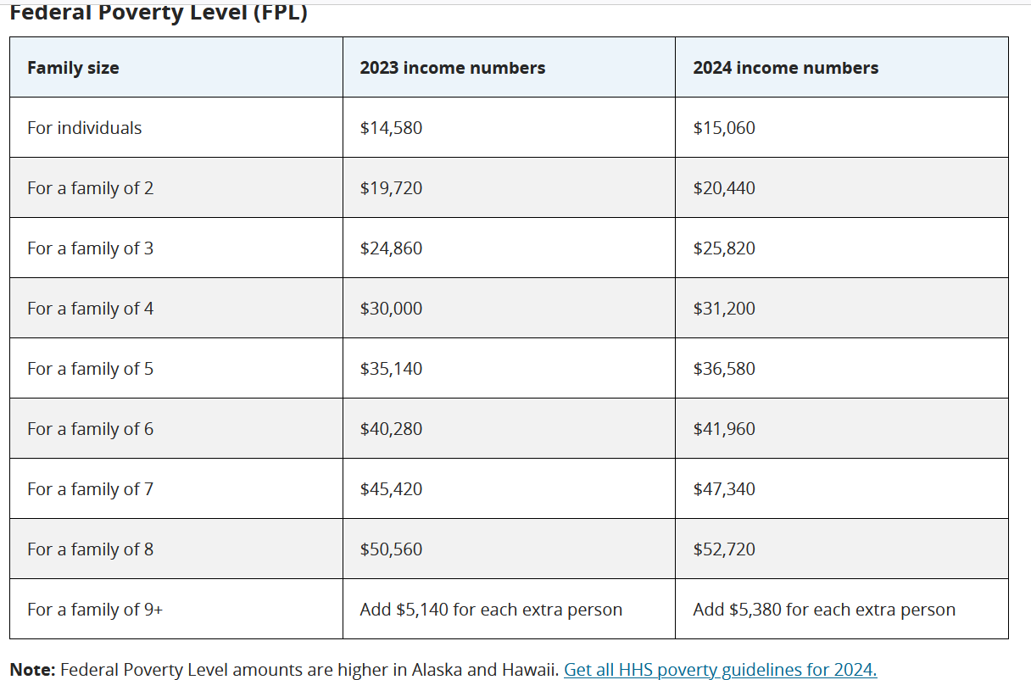

STUDENT LEARNING OUTCOMES
- Distinguish between international financial management and domestic financial management.
- Explain the forms of business ownership.
- Identify and evaluate operational goals and governance of different business ownership forms.
- Analyze the characteristics of an ideal currency.
- Explain the currency regime choices.
- Explain the balance of payments and related accounts.
- Identify balance of payment activities.
- Analyze exchange rate changes.
- Explain how current and past economic, regulatory, and social forces can lead to financial challenges.
- Explain the definitions and differentiate among types of foreign exchange financial instruments.
- Analyze the interaction among changing currency values, cross exchange rates and opportunities arising from intermarket arbitrage.
- Examine how price levels and price level changes (inflation) determine the exchange rate.
- Explain how foreign exchange markets reflect expectations held by market participants.
- Explain how foreign currency derivatives are quoted, valued, and used.
- Define interest rate risk, and examine how it can be managed.
- Explain and compare the major foreign exchange exposures.
- Define operating exposure and evaluate strategic alternatives to managing operating exposure.
- Analyze the linkage between cost and availability of capital.
- Explain how the weighted average cost of capital for an MNE compares with its domestic counterpart.
- Describe the many barriers to penetrate foreign equity markets.
- Evaluate the various internal and external sources of funds available for the financing of foreign subsidiaries and MNE's.
- Identify factors and forces that must be considered in the determination of where MNEs’ invest.
- Illustrate the methods for foreign investment.
- Examine the methods for evaluating and funding large global projects.
- Describe the principles of cross-border mergers and acquisitions.

UNITS OF INSTRUCTION

Chapter or Learning Unit | Book Chapter | Exam

outcomes include the following competencies:
Multinational Financial Management: Opportunities and Challenges | 1 | 1
The International Monetary System | 2 | 1
Balance of Payments | 3 | 1
Financial Goals and Corporate Governance | 4 | 1
Foreign Exchange Market | 5 | 2
International Parity Conditions | 6 | 2
Foreign Currency Derivatives Futures and Options | 7 | 2
Special Topic 1 - Review of Time Value of Money | NA | 2
Transaction Exposure | 10 | 3
Translation Exposures | 11 | 3
Operating Exposure | 12 | 3
Special Topic 2 – International Capital Budgeting | NA | 3
Global Cost and Availability of Capital | 13 | 4
Funding the Multinational Firm | 14 | 4
Foreign Direct Investment Theory and Political Risk | 17 | 4
Multinational Capital Budgeting & Cross Border Acquisitions | 18 | 4

  - Critical Thinking
  - Effective Communication
  - Quantitative Literacy
  - Information Literacy

GENERAL EDUCATION OUTCOMES
Columbus State Community College's general education outcomes are an integral part of the curriculum and central to the mission of the college. The faculty at Columbus State has determined that these

COURSE MATERIALS REQUIRED - TEXTBOOK, MANUALS, REFERENCES, AND OTHER READINGS
    - Fundamentals of Multinational Finance, 6th Edition – Moffett, Stonehill, Eiteman
    - MyLab; Pearson online
    - Financial Calculators are required, and these will have Time Value of Money (TVM), Net Present Value (NPV), and Internal Rate of Return (IRR) calculation functionality. Some examples are:
      - TI 83 or TI 84 (which are required for several math classes), TI BA II Plus ($30-$40 & easier to use)
      - Excel can be used instead of this calculator, but on tests you will be under a lockdown browser, so you will want a calculator for testing purposes.

GENERAL INSTRUCTIONAL METHODS
This course utilizes reading assignments from the text, video recordings, assignments, projects, quizzes, and tests.
The course should be accessed frequently in order to stay current with posted announcements and possible discussion board conversations. For finance courses, experience shows that breaking up study time into more frequent smaller units is more effective than a few large blocks of time. There is a test review for each unit. Experience also shows that answering these questions as you study each chapter is more beneficial than just looking at the review questions prior to the test.
This course consists of four units. There will be a test for each unit. Each of these units will be divided into self-contained modules. Each module will follow the same pattern of reading assignments from the text, videos, projects, and quizzes.

STUDENT RESPONSIBILITIES - As a student in this course, it is your responsibility to:
- Read all course materials and information including the course syllabus and videos.
- Have already passed FMGT 1101 – Personal Finance (and recommended FMGT 2201)
- Complete all assignments and tests according to the course calendar.
- Participate on the discussion boards in timely fashion if required.
- Login to the Web site periodically during the week to monitor class announcements.
- Assignments must be submitted by the appropriate due date.
- All work must be completed individually by the student registered for this course.

STANDARDS AND METHODS FOR EVALUATION

Tests (700 points):

There will be 4 tests during the regular class schedule and a final test. Each test will be worth 175 points. These tests will cover the material listed in the course schedule and will include information contained in the course lectures, assignments, projects, PowerPoints, quizzes, and the assigned reading. The tests consist of multiple-choice questions. The material covered in each testis as follows:
Required:
Test 1 – Learning Units 1 through 4 (Chapters 1-4)
Test 2 – Learning Units 5 through 8 (Chapters 5-7 plus Special Topic 1)
Test 3 – Learning Units 9 through 12 (Chapters 10–12 plus Special Topic 2)
Test 4 – Learning Units 13 through 16 (Chapters 11-14)
Make-up / Replacement or Optional: Test 5 – Comprehensive Final
If any test 1-4 is missed for any reason, test 5 is taken as the make-up. Therefore, during the semester, tests are not made up. The grade on test 5 will be substituted for any one test missed. This final test is also optional for anyone who has taken all four regular tests. In this case, the lowest grade of the five will be dropped (i.e., replacement).

All tests will be taken on a computer of the students’ choosing. A lockdown browser with camera and audio recording will be utilized. You will be allowed a one page (front & back) personal assistance form (cheat sheet) that you create. All tests will be timed and limited to 60 minutes. Once you start a test, you must complete it. This means you will need to study like a closed book test. You will have a window of several days to take all tests as noted on the Course Calendar.
Discussion Boards (DBs): There is a non-grade student forum in this course. Some could be added for information or extra credit.

Quizzes (126 points):
There will be a 9-point quiz for each of the 14 textbook chapters covered in the course. The quizzes will be in the MyLab homework system from Pearson. These are open book with no time limit, and you get five attempts at each quiz. Due dates are on the course calendar. Quizzes must be completed and submitted by 11:59 on their respective due date. You lose 33% (3 points) per day for late quizzes.

Project Assignments (90 points) & Special Topic Homework Assignments (84 points)
There are three projects, each worth 30 points, and two Special Topic Assignments, each worth 42 points. Due dates are on the course calendar. These must be completed and submitted by their respective due date and are due at 11:59 pm EST on the due date. More details for each on Blackboard. These should be submitted via Blackboard, not by email if at all possible. PLEASE DO NOT SKIP these assignments! They are worth almost 18% of your grade in this class!

GRADING SCALE AND POINT DISTRIBUTION

Test #1 (Chapters 1-4) | 175 points
Test #2 (Chapters 5-7 plus Special Topic 1) | 175 points
Test #3 (Chapters 10-12 plus Special Topic 2) | 175 points
Test #4 (Chapters 13-16) | 175 points
Test #5 (Comprehensive and optional) |  | (175 optional)
Tests: Best 4 out of 5 for 700 points
14 Quizzes worth 9 pts each | 126 points
Project Assignments - 30 points each | 90 points
Special Topic Homework Assignments (2 for 42 points each) | 84 points
Total | 1000 points

Grade Scale:

Letter | Percentage | Points
A | 90% + | 900-1000 points
B | 80% + | 800-899points
C | 70% + | 700-799 points
D | 60% + | 600-699 points
E | Below 60% | below 600 points

ONLINE GRADE BOOK
This course will utilize the online grade book in Blackboard. The student is responsible for monitoring of grades. Any discrepancies or missing grades should be brought to the attention of the instructor within a week after grades are posted.

COLUMBUS STATE TESTING CENTER
The Testing Center will only be utilized if you need resources they have due to a disability, if you do not have a computer with a camera or audio capability, or if you have an unstable testing environment due to wifi issues or due to not having a quiet space. Your instructor will work with you to determine the best testing location with you. A one-week minimum notice is needed to utilize the Testing Center.

LATE ASSIGNMENT POLICY
No late assignments will be accepted.

INSTRUCTOR EXPECTATIONS
You need to use your CSCC e-mail account when corresponding with your professor. The CSCC e-mail servers block spam and may block your e-mail if you use a different account. If you send viruses in your

email attachments then they will also be blocked. If you have trouble with your password or CSCC e-mail then call the CSCC help desk at 614-287-5050.

When sending email, it is easiest to use the ”Email Instructor” button within Blackboard. If not, be sure to type FMGT 2242 somewhere in the subject line. This will identify you as a class member.
For all submissions: Please put name on each page and use Microsoft Word or Excel. As the catalog states Business Program Majors are expected to have mastered MSWord, Excel, PowerPoint, and Access software applications. Courses are offered in our Business Office Applications (BOA) programs to accommodate these skills.

Unless specifically directed by the instructor, each student in this course is expected to complete ALL assignments independently, on her/his own. Do not copy and paste homework or portions of web sites under any circumstances without proper references. Any time you utilize a web site for this class, reference that web site on a separate reference page using proper formatting. This will inform your instructor that you used the site properly and legally. To not cite these is plagiarism.

Plagiarism in any form is a violation of Columbus State Community College. See the Student Code of Conduct section of the syllabus.

ATTENDANCE POLICY
Attendance will be measured by the successful, timely completion of course assignments and tests.
Simply “showing up” or logging into Blackboard will not count as attendance.

INSTRUCTOR FEEDBACK AND AVAILABILITY
Grades for assignments and tests will be posted within 7 business days after the due date for the assignments and tests. The instructor will respond to emails and voicemails within 48 hours Monday through Friday. The instructor may periodically check email during evening and weekend hours, but reserves the right to not check email during this time.

