Columbus State Community College

Econ 1110 Introduction to Economics WEB SPRING 2024
Professor Scott Hunt, Ph.D.
TL 322
e-mail: shunt@cscc.edu

Read all the syllabus information carefully. Then go through the course website and CLICK on EVERY BUTTON to learn what's where and to get a look at what this course involves.

BE SURE TO CHECK UNDER CALENDAR DUE DATES or course calendar for key dates and deadlines. Deadline dates are just that, deadlines. You may take any of the exams PRIOR to the deadline. Waiting to the last possible day and hour to take an exam is NOT a good strategy. You will also be a little behind in your material if you wait until the last day.

Readings are listed on the calendar as well…once you finish an exam begin the next readings (do not wait until the day the readings are posted).

Please send a "hello" message to your instructor at shunt@cscc.edu so I know you are attending. I’ll use your cscc.edu student address for all feedback. Blackboard only uses these student mailboxes, so if it is not your primary box, you need to have your student email forwarded to your primary account. All announcements placed on Bb will also be emailed to your student mailbox.

PREREQUISITES
Completion of Math 1030 & placement into English 1100 (Beginning Composition). Simply put, you need good algebra and graphing skills, plus the ability to write effectively using Standard English.

TEXT
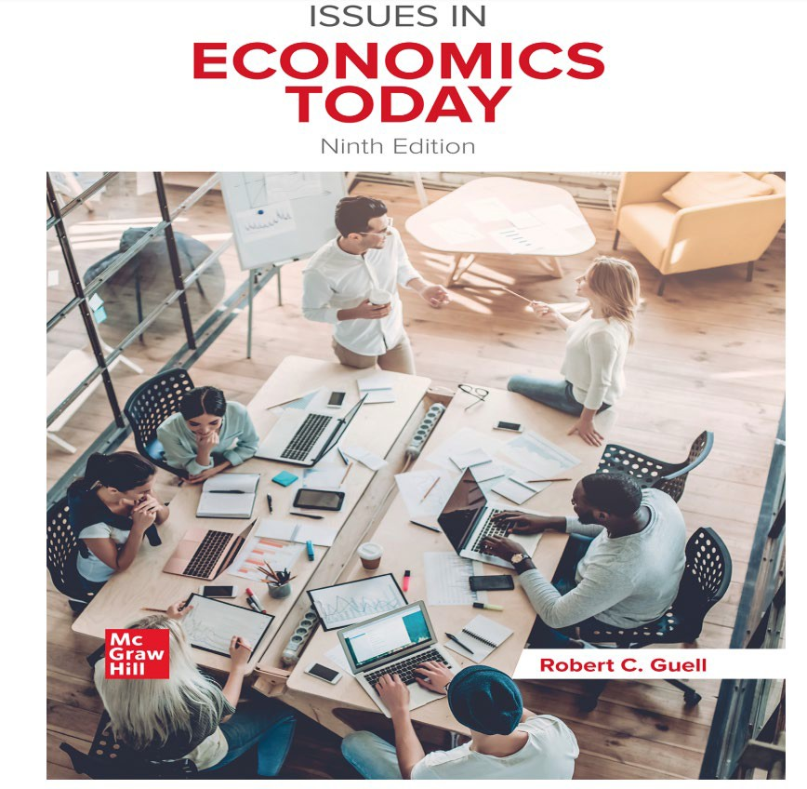
Issues in Economics Today 9th edition by Robert C. Guell. McGraw-Hill

To register: follow the instructions on this link: http://video.mhhe.com/watch/UZnyThhiZgbh3pKQFBiQUZ?
If you don’t have a code you at the beginning of the semester you do as above and locate the button for 2 free weeks. This will allow you to get some work done in time to get your text.

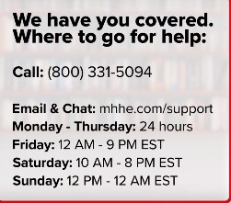
McGraw Hill support:

COURSE DESCRIPTION
Econ 1110 is an introductory course in economic terms and reasoning, with applications to contemporary social issues and current events. You will be learning some basic micro- and macroeconomic terms and concepts with an eye to using them to engage in meaningful discussions of today's economic and social issues. This survey course does not delve as

deeply into economic constructs and modeling as do the Principles of Microeconomics (ECON 2200) or Principles of Macroeconomics (ECON 2201) courses.

The Ohio Board of Regents classifies class credit according to the preparation time required by students. This is a 3-credit course. It is anticipated that a student in Econ 1110 will dedicate 9 hours per week to this course.
Do keep in mind that Internet Econ 1110 is not a "quickie" version of the Columbus State Intro to Econ course. Distance learning offers an alternate learning vehicle, but course requirements and standards are the same for online and in-class students.
For this course Econ 2200, students are expected to demonstrate the skills associated with the Institutional Learning Goals identified below:
- ILG#1 Critical Thinking
- ILG #2 Ethical Reasoning
- ILG #3 Quantitative Skills
- ILG #4 Scientific Literacy
- ILG #6 Communication Competence
- ILG #7 Cultural and Social Awareness

- In class students are assessed on their achievement of these outcomes. Names will not be used when reporting results. Outcomes-based assessment is used to improve instructional planning and design and the quality of student learning throughout the college.

COURSE OBJECTIVES 1
To introduce you to the most important principles of economics and show you how to apply them to the world in which we live. Additionally, the mission of the College, and this course, includes the following General Education Outcomes: critical thinking, effective communication, community and civic responsibility, quantitative literacy, scientific and technological effectiveness, and information literacy.

HARDWARE AND SOFTWARE REQUIREMENTS
PC with (at least) Windows7and Internet access using Firefox (preferred…fewer glitches) Explorer, or Chrome. You will also need a CSCC student e-mail account. Call 614-287-5050 for additional information.

Having technical problems? Learner Support Services is available to assist students with questions related to software and hardware from 7:30am to 10pm Monday through Thursday and from 7:30am to 6pm on Fridays. You can reach them at 614-287-5050.

COMMUNICATION & FEEDBACK
Exam and paper scores will be posted on Blackboard. Additional feedback will be e-mailed. As this is an online course, most of our communication will be via e-mail. The e-mail address for this class is shunt@cscc.edu .
You should expect a response to an e- mail question within 2 business days.

ACADEMIC INTEGRITY
As an enrolled student at Columbus State Community College, you have agreed to abide by the Student Code of Conduct as outlined in the Student Handbook. You should familiarize yourself with the Student Code. The faculty at Columbus State expect you to exhibit high standards of academic integrity. Any confirmed incidence of academic misconduct, including plagiarism and other forms of cheating, will be treated seriously and in accordance with College Policy and Procedure.

Having trouble with an assignment? DO NOT take a shortcut that puts you on the wrong side of the integrity divide. DO contact your instructor, who is always most willing to help students understand the task at hand. I look forward to establishing a relationship with you based on mutual respect. YOU are responsible for what you achieve in this class! Neither cheating nor plagiarism will be tolerated. Plagiarism is the act of representing directly or indirectly someone else’s speech, wholly or partially, as your own; quoting without acknowledging the true source of quoted material; copying and handing in another person’s work with your name on it; and similar infractions. Even indirect quotations, paraphrasing, etc. can be considered plagiarism unless sources are properly cited. Cheating or plagiarism will result in a MINIMUM PENALTY of a ZERO on that assignment and will be reported to the Dean.

ETC.
If you decide not to complete this course, please formally drop. Failure to officially withdraw will result in an "E" on your transcript. For help with schedule changes, see Registration Office staff in Madison Hall.
FINANCIAL AID ATTENDANCE REPORTING
Columbus State is required by federal law to verify the enrollment of students who participate in Title IV student aid programs and/or who receive educational benefits through the Department of Veteran's Affairs. It is the responsibility of the College to identify students who do not commence attendance or who stop attendance in any course for which they are registered and paid. Non-attendance is reported quarterly by each instructor and results in a student being administratively withdrawn from the class section.

Attendance and participation in the course means that you have made contact with the instructor at least once every 2 weeks in the course. Participation includes the “hello” email at the beginning of the semester, exams taken, LearnSmart completed and ABAs completed.

Please contact the Financial Aid Office (614-287-2648) for information regarding the impact of course withdrawals on financial aid eligibility.

DISABILITY SERVICES
It is College policy to provide reasonable accommodations to students with documented disabilities. To request such accommodations because of a physical, mental or learning disability, contact the Department of Disability Services, first floor Eibling Hall, 614-287-2570 (Voice/TTY) and let your instructor know by Week 2 so we can talk about ways she might be helpful to you.

OUTCOMES ASSESSMENT
Columbus State Community College is committed to assessment (measurement) of student achievement of academic outcomes. The process addresses the issues of what you need to learn in your program of study and if you are learning what you need to learn. The assessment program at Columbus State has four specific and interrelated
purposes: (1) to improve student achievement, (2) to improve teaching strategies, (3) to document successes and identify opportunities for program improvement, (4) to provide evidence of institutional effectiveness.

COURSE REQUIREMENTS
See how to access the assignments folder in Course information foe explicit details on ALL assignments

EXAMS Are ONLINE
See the how to access folder under the Course information button on directions.

Access them by clicking on the Exam button on BB.

You will be assessed over three units. There are two exams in each unit:

- a foundation exam (everyone takes);

- AND your choice (Unit 1: Exam A or B; Unit 2: Exam C or D; Unit 3: Exam E or F) of one of the two grouping exams (depends upon which group of applied chapters you choose to read).

You must read the foundation chapters in each unit. There are also TWO group exams in each unit. After completing the foundation chapters in a unit, you MUST CHOOSE ONE GROUP to study. You have a choice.
After reading the GROUP you have chosen there is an exam on that group as well. A file in the COURSE INFORMATION BUTTON has the CALENDAR DUE DATES to find deadline dates (last date available and you can take it any time prior to the deadline) for the current semester.

Unit | Foundation exam  (Everyone takes these) | Chapters | Points | Grouping Exam (for each unit you Choose 1 of  these 2) | Chapters | Points
1 | 1everyone  takes this) | 1-5 | 60 | Choose  A or B | - 30,33,36,47  - 26,35,36,42 | 50
2 | 2everyone  takes this) | 6-8  17,18 | 60 | Choose  C or D | - 19,20,24,28  - 20,21,22,34 | 50
3 | 3 everyone  takes this) | 9-12  40 | 60 | Choose  E or F | - 14,29,38,41  - 15,16,29,41 | 50

See the how to access folder under the Course information button on the path you take through the course.
Exams are found by clicking on the EXAM button. You may only open an exam ONCE. Be sure you have a solid connection and hit submit after completing the exam. You may NOT SAVE or re-enter an exam. There are several bonus questions on each exam (you will see more points available than what you are graded out of…hence it is possible to receive over 100%).

The exam deadlines are firm. Late exams? ONLY in the case of a documented medical emergency (NOT a scheduled doctor appointment or procedure) or a death in your immediate family (mother-father-sibling-spouse-own child.) No exceptions!

Exam results will be posted on Blackboard.

APPLICATION PAPER
This semester you will be writing one 100-point application paper. Your task in this paper is two-fold:
- to demonstrate a thorough understanding scarcity and opportunity cost via a PPC or budget line

- to showcase your ability to link theory and practice.
Click on PAPER for complete instructions regarding this assignment and how to format your paper. Do note that your paper must be
  - submitted as a Word document (with a .docx tag) e-mail attachment
  - to a message from your CSCC.student e-address to
shunt@cscc.edu. (Do not use the drop box on BB)

  - The e-mail date counts as a paper's submission date.
  - LATE ASSIGNMENTS earn a 5 point per day deduction
  - Click the PAPER button for more information about how to write/submit your paper.

LearnSmart’s
Each chapter you read has a LearnSmart you will need to complete. Each LearnSmart will take you 10-25 minutes to complete. You will read 27 chapters in this course (15 from the foundations and your choice of 12 by choosing between each group). Each is worth 10 points from completion by their respective deadlines. You may only complete 27 LearnSmart’s and the points from learn smarts are capped at 270 points.
See the “How to access” folder under the Course information button on directions.

When you get to the GROUPS choose one, say A or B , and do those 4 LearnSmarts…. 40 points, BUT realize that the Group NOT Chosen will have 0s as scores. Do NOT worry they do NOT impact your grade…they are fillers.

Application Based Activities (ABA)

Each of the foundation units have a number of ABAs. These are a running conversation that applies the content. You are to read the conversation the data presented and answer the questions posed within the conversation.
There are multiple choice questions as well as numeric questions so have a calculator handy. You may access these twice. Each is valued up to 20 points. We will keep your best 15 (that is we drop the lowest 5). These are estimated to take 15-20 minutes each.

See the “How to access” folder under the Course information button on directions.

EXTRA CREDIT
There are three additional Application Based Activities worth 15 points each.

Grading
Requirement | Points of each assignment | Total points
1 Application Paper | 100 points | 100 points
3 foundation exams | 60 points | 180 points
3 group exams | 50 points | 150 points
Learn smarts | 10 points | 270 points
ABAs | 20 points | 300 points
TOTAL |  | 1000

Letter Grade | Percentage | Total Points
A | 90-100% | 900+
B | 80-89% | 800-899
C | 70-79% | 700-799
D | 60-69% | 600-699
E | Below 60% | Below 600

THERE IS NO CURVE IN THIS COURSE.

FYI: Blackboard will show more than 1000 points due to the extra credit rest assured you are graded out of 1000 points at the end of the semester… look at total graded points for your current accumulation.
Your % = (points obtained/1000). I round upward to the nearest whole number

NOTE: You only complete the LearnSmarts of ONE group out of 2. You will see 0s in the other LearnSmarts... one reason you cannot look at the % on BB.

