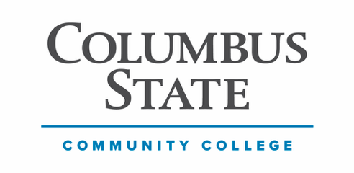
Columbus State Community College

Division: Business & Engineering Technology

Department: Digital Art, Media & Design

Digital Design and Graphics Program (live link)

COURSE NUMBER: DDG 1101 COURSE TITLE: Survey of Digital Design
INSTRUCTOR: CONTACT:
CREDITS: 3 CLASS/CONTACT HOURS PER WEEK: 3 Lecture PREREQUISITES: None

DESCRIPTION OF COURSE
DDG 1101 provides an overview of the contemporary Digital Design & Graphics industry and the creative processes that drive it. Students are introduced to key areas of professional practice, including design principles and elements, visual communication, color theory, typography, branding, and corporate identity. From advertising and marketing communications to social media and brand strategy, the course explores how imagery, layout, and storytelling work together across print and digital platforms. Students will develop foundational skills using the industry standard, cloud-based design platforms Canva and Adobe Express, while emphasizing creative problem-solving, visual literacy, and collaboration within real-world design environments.

COURSE STUDENT LEARNING OUTCOMES
- Identify and apply the fundamental principles and elements of design in visual compositions.
- Demonstrate an understanding of color theory and its application in print and digital media.
- Use typography effectively to enhance communication and strengthen visual hierarchy.
- Create original visual content that reflects basic branding and corporate identity concepts.
- Develop design solutions that integrate imagery, layout, and storytelling across media platforms.
- Design and publish projects using the cloud-based tools Canva and Adobe Express, in alignment with industry standards.
- Evaluate visual communication pieces for effectiveness, clarity, and alignment with client goals.
- Analyze the structure and roles of teams within a modern digital design or creative agency.
- Explore career pathways within the Digital Design & Graphics industry, including roles in branding, advertising, marketing, and multimedia design.

PROGRAM OUTCOMES
- Explain the Digital Design and Graphics business and be able to interact with clients, marketing executives, copy writers, web designers, photographers and printing companies.
- Utilize the most widely used industry software programs: Adobe Express and Canva, Photoshop, Adobe Illustrator, Adobe InDesign, Storyboard Pro.
- Identify the management of color for print media, photography, and interactive media.
- Recognize and interpret digital photography and how to implement in all creative areas.
- Examine how an advertising agency organization works on projects for clients.
- Explain and discuss how to work in a creative environment as an individual and as a team member.
- Introduce the use of Artificial Intelligence (AI) in design development.
- Effectively prepare and present a creative portfolio.
- Recognize the importance of good verbal and written communications.

OUTCOMES BASED ASSESSMENT OF STUDENT LEARNING
For this course, students are expected to demonstrate the skills associated with the Institutional Learning Goals (ILG) identified below:
- Critical Thinking
- Communication Competence
- Cultural and Social Awareness
In class students are assessed on their achievement of these outcomes. Names will not be used when reporting results. Outcomes-based assessment is used to improve instructional planning and design and the quality of student learning throughout the college.

COURSE MATERIALS REQUIRED
A computer meeting the recommended technical specifications capable of running Adobe Express & Canva, along with a reliable high-speed internet connection, is required.

TEXTBOOK(S), MANUALS, REFERENCES, AND OTHER READINGS
Free e-Text
White Space Is Not Your Enemy, Rebecca Hagen & Kim Golombisky, 3rd Ed., ISBN: 978-1-138-80464-7

GENERAL INSTRUCTIONAL METHODS
Reading assignments, video lectures, and media presentations.

STANDARDS AND METHODS FOR EVALUATION
Each student's course grade will be comprised of the following weighted components averaged according to the following ratio based on the standard 100-point grading scale for each category as specified by the college.

5 Quizzes at 2% each = 10%
10 Projects at 90% each = 90%

Project #1 | 5% | Intro to Canva
Project #2 | 10% | Design a Mood Board/Restaurant
Project #3 | 10% | Poster Layout
Project #4 | 10% | Analyze Advertisements
Project #5 | 10% | Ad Design
Project #6 | 10% | Logo Design
Project #7 | 5% | Infographic
Project #8 | 10% | Social Media
Project #9 | 10% | Web Splash Page
Project #10 | 10% | Slideshow – Open Theme
Total 100%

GRADING SCALE
A = 90-100 Points
B = 80-89 Points
C = 70-79 Points
D = 60-69 Points
E = 59 Points and below

ATTENDANCE POLICY & PARTICIPATION REPORTING
Columbus State is required by federal law to verify the attendance of students receiving Federal Title IV aid or Veterans Affairs benefits. Instructors must report students who never attend or are failing a course, which may result in automatic administrative withdrawal. Attendance is determined by each instructor based on “significant and meaningful academic activity,” as defined by the CSCC Financial Aid Office and Enrollment Services (must be passing the course at the time of reporting). Contact the Financial Aid Office for details on how withdrawals may affect eligibility.
Note: Quizzes will NOT be accepted after the deadline so please plan accordingly. Do not wait until the last minute to discover that you are having trouble with your browser settings. All late projects will be marked off 5% per day (even a partial day). All missed quizzes or exams receive a zero. Any project more than 5 days late will not be accepted.

AI & DESIGN
The Digital Design & Graphics program:
- Recognizes AI's integral role in future design practices.
- Views generative AI as a co-creation tool for rapid translation and prototyping.
- Emphasizes understanding AI as a platform for imagination, ideation, and problem-solving in design education​​.
- Highlights the importance of understanding the ethical implications of incorporating AI in design practice.
- Educates students about biases in data and algorithms, promoting awareness of open-source AI models and efforts to democratize AI technology​​.
This DDG 1101 course: the focus is on mastering the functionalities of Canva and Adobe Express (and any other subsidiary programs we introduce) while students practice some real-world design projects. The use of any artificial intelligence tools outside of what is offered within these two programs is not permitted. Utilizing other AI tools for your projects, in this course, especially to generate project images, will be considered plagiarism and will lead to a failing grade for that project. Remember, the image origins are always embedded in the image’s metadata and EXIF data. AI images are easy to identify in that way (even if altered). The course is designed to foster active learning and hands-on experience, enabling students to demonstrate their work process and develop skills in using Canva and Express. Additionally, the course aims to help students cultivate their unique style and voice in design even though we are using a template driven approach. AI is ever evolving, and students will use it in many varying degrees through every other course in the DDG program.

STUDENT CODE OF CONDUCT
As an enrolled student at Columbus State Community College, you have agreed to abide by the Student Code of Conduct as outlined in the Student Handbook. You should familiarize yourself with the student code. Columbus State expects you to exhibit high standards of academic integrity, respect, and responsibility. Any confirmed incidence of misconduct, including plagiarism and other forms of cheating, will be treated seriously and in accordance with College Policy and Procedure 7-10.

PLAGIARISM
According to the Student Code of Conduct and Academic Misconduct Policy, plagiarism includes submitting work presented as one’s own that has been wholly or partially created by another individual—for example, using images sourced online in place of original work. Intent is not a determining factor; plagiarism, whether deliberate or unintentional, constitutes a violation of academic integrity and is treated as academic dishonesty. So do your own work.

COLLEGE SYLLABUS STATEMENTS
Columbus State Community College required College Syllabus Statements on College Policies and Student Support Services can be found at www.cscc.edu/syllabus or on the College website Quick Links “Syllabus Statements”.

UNITS OF INSTRUCTION

WEEK | UNIT OF INSTRUCTION | LEARNING OBJECTIVES/GOALS | ASSESSMENT METHODS | ASSIGNMENTS | ASSIGNMENT DUE DATE
Week 1  MM DD | What is Design  Canvas vs. Express  Canva Interface & Use | Intro to Course; Intro to Digital Design concepts; Intro to digital design platforms; Make sure you have a Canva and Adobe Express account. | QUIZ 1 | Complete your weekly content folder. Watch the videos/read the tutorials. Create Canva account.  Complete Quiz on time. | QUIZ 1  Due by 11:59PM on Sunday night of this week
Week 2  MM DD | Principles and Elements of Design | Understand all elements and principles of design and how they interact to make effective visual communication mediums. Introduce yourself using a Canva template | PROJECT 1  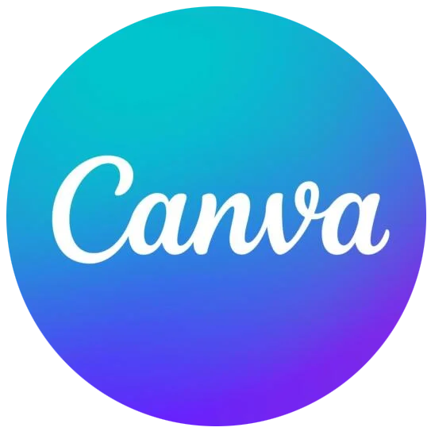 | Complete your weekly content folder. Watch the videos/read the tutorials and complete project on time. | PROJECT 1  Due by 11:59PM on Sunday night of this week
Week 3  MM DD | Typefaces & Fonts | Recognize different typeface styles and effects; use typefaces to create visual interest and hierarchy | QUIZ 2 | Complete your weekly content folder. Complete Quiz on time. | QUIZ 2  Due by 11:59PM on Sunday night of this week
Week 4  MM DD | Color | Master color theory basics, including color reproduction on mediums and color properties. Develop and design a restaurant name using typefaces and colors | PROJECT 2 | Complete your weekly content folder. Watch the videos/read the tutorials and complete project on time. | PROJECT 2  Due by 11:59PM on Sunday night of this week
Week 5  MM DD | Layout | Learn where to place visuals and text together to control viewers’ eyes across various mediums. Design posters. | PROJECT 3   | Complete your weekly content folder. Watch the videos/read the tutorials and complete project on time.  Create Express account. | PROJECT 3  Due by 11:59PM on Sunday night of this week
Week 6  MM DD | Advertising Analysis | Learn the key elements of advertisements; Analyze advertisements based on the principles and elements of design and their ability to influence. Research and discuss 2 examples of successful advertising and 1 example of unsuccessful advertising. | PROJECT 4 | Complete your weekly content folder. Watch the videos/read the tutorials and complete project on time. | PROJECT 4  Due by 11:59PM on Sunday night of this week
Week 7  MM DD | Photography & Illustration | Learn the difference between photographs and illustrations and strategies for when to use each; understand the difference between objective and subjective imagery | QUIZ 3 | Complete your weekly content folder. Complete Quiz on time. | QUIZ 3  Due by 11:59PM on Sunday night of this week
Week 8  MM DD | Ad Design | Work with photos and illustration to create powerful visual messaging; Learn where to source images; Create a poster or ad using illustrations and/or photos. | PROJECT 5 | Complete your weekly content folder. Watch the videos/read the tutorials and complete project on time. | PROJECT 5 Due by 11:59PM on Sunday night of this week
Week 9  MM DD | Logo Design | Recognize what makes logos impactful and recognizable. Develop and design a variety of logos. | PROJECT 6  AND | Complete your weekly content folder. Watch the videos/read the tutorials and complete project on time. | PROJECT 6  Due by 11:59PM on Sunday night of this week
Week 10  MM DD | Infographics | Understand the role and function of data visualization and infographics. Create an infographic. | PROJECT 7 | Complete your weekly content folder. Watch the videos/read the tutorials and complete project on time. | PROJECT 7  Due by 11:59PM on Sunday night of this week
Week 11  MM DD | Social Media. | Develop a multimedia content toolbox; Execute designs for a brand/theme and develop a simple schedule for content. | PROJECT 8  OR | Complete your weekly content folder. Watch the videos/read the tutorials and complete project on time. | PROJECT 8  Due by 11:59PM on Sunday night of this week
Week 12  MM DD | Web Design | Understand how the web works and its unique challenges for design and content; Learn the anatomy of web pages; Design web splash pages | PROJECT 9  OR | Complete your weekly content folder. Watch the videos/read the tutorials and complete project on time. | PROJECT 9  Due by 11:59PM on Sunday night of this week
Week 13  MM DD | Student to Professional | Learn about the different roles in the design industry; Understand the skill sets required for these roles; Learn the printing/paper vernacular and processes. | QUIZ 4 | Complete your weekly content folder. Watch the videos/read the tutorials. Complete Quiz on time. | QUIZ 4  Due by 11:59PM on Sunday night of this week
Week 14  MM DD | Design Showcase – Final Presentation | Work on PROJECT 14 – See Below | QUIZ 5 | Complete your weekly content folder. Watch the videos/read the tutorials and complete Quiz on time. | QUIZ 5  Due by 11:59PM on Sunday night of this week
Week 15  MM DD | Design Showcase – Final Presentation | Create impactful and powerful presentations; Develop a slideshow featuring the skillsets learned throughout the semester focusing on the medium or output students are most interested in | PROJECT 10 | Complete your weekly content folder. Watch the videos/read the tutorials and complete project on time. | PROJECT 10  Due by 11:59PM on Sunday night of this week
Course Over |  |  | No Final Exam

