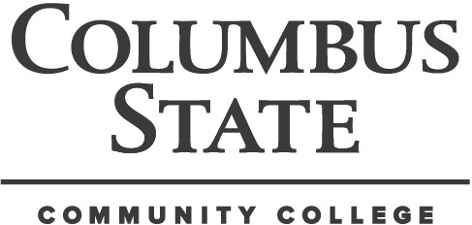
Columbus State Community College Construction Sciences & Engineering Technology Department
Construction Management

CMGT 2994-W01 Special Topics: Rush Creek Village Experience 3 ONLINE
Instructor: Marcia Rees Conrad, LEED AP, AIA Office Hours: by appointment Office: 205 Davidson Hall
Phone: 614 432-8393
Fax: 614-287-3644 (CSET Dept)
E-mail: mconradarchitect@gmail.com

SYLLABUS
Course Description

This Special Topics courses will focus on the history of architecture and creators as it relates to Rush Creek Village. This will include collecting data and documenting a historical residence in Rush Creek Village neighborhood. The course is structured with lectures, site visits, house tour hand and photographic documentation of site plan, floor plan, and elevations; as well as building a 1/80th scale buildings to use on site, and 1/4 “ model. Final project will be a portfolio of written and photographic documentation.

Course Prerequisites

None other than a determined interest in being a part of a rare and unique opportunity.

Course Objectives
Students successfully completing this course will participate in documentationdesigns and preserving a historical treasure, perform documentation and assessments of a design atypical of past or present day architecture.

Textbook (Recommended)

An Experiment in Organic Architecture, Rush Creek Village SharynTalbert, Marcia Rees Conrad.
References
Green Building Materials: A Guide to Product Selection and Specification, 2nd Ed. 2006. R. Spiegel &
D. Meadows. Wiley & Sons, Hoboken NJ
CSI Project Resource Manual, 5th Ed., Construction Specifications Institute, 2005 McGraw Hill www.usgbc.org www.cgbf.org www.epa.gov/greenbuilding www.bdc.com www.bdg.org
Instructional Methods

Online format with presentations, tests, exercises, site visits, and projects.

Methods and standards of evaluation

Participation, exercises, site visits, and research project.

CMGT WO1 Rush Creek Village Experience 3 Autumn 2014
Special Course Requirements

This is a unique opportunity in design and construction for each student. Attendance during site visits are paramount for garnering the most of this special topics course. Reflections should be an in-depth analysis of the presentation or visit, reflecting at a minimum, instruction up to that point in the course. The final portfolio shall include written, model and photographic evidence of learning and analysis.

All research materials shall be submitted to the instructor. Submissions determined to fall within the plagiarism guidelines of CSCC will be given a “zero” and the student shall receive and “E” for the course.

Grade Composition |  | Grade ranges
Participation | 10 % | A = 90-100%
Site visits | 30 % | B = 80-89.9%
Exercises/ tests | 30 % | C = 70-79.9%
Portfolio 30 % |  | D = 60-69.9%
TOTAL 100 % |  | E = below 60%

Attendance

College policy will be followed and attendance will be noted each class period. Please advise your instructor prior to any situation that requires your absence.

Cell phones and electronic devices

Cell phones must be turned off or put on vibrate during the class period. If you must use your cell phone during class, please inform the instructor of the emergency or personal business and leave the room or laboratory area. Anyone using a cell phone during class for any reason will be required to leave the room or laboratory area and will not be permitted to return until the telephone call is complete. Use of any other personal electronic device, except your calculator, is not permitted during class or during quizzes or exams.
General Education Goals

The following are the general education outcomes. The specific outcomes addressed by this course are listed on the individual unit outlines: Critical Thinking, Effective Communication.
Quantitative Literacy. and Scientific and Technological Effectiveness. In class you are assessed and graded on your achievement of the outcomes for this course. You may also be required to participate in broader assessment activities.

Student Code of Conduct

As an enrolled student at Columbus State Community College, you have agreed to abide by the Student Code of Conduct as outlined in the Student Handbook. You should familiarize yourself with the student code. The Columbus State Community College expects you to exhibit high standards of academic integrity, respect and responsibility. Any confirmed incidence of misconduct, including plagiarism and other forms of cheating, will be treated seriously and in accordance with College Policy and Procedure 7-10. We fully realize that life will present you with situations which may cause you to fall behind or even consider dropping this course. We want to know that we want to do everything possible to assist you in overcoming these obstacles. Please speak to your instructor, advisor or other faculty person as soon as possible and give us a chance to help. No matter is too trivial or unique.

CMGT WO1 Rush Creek Village Experience 3 Autumn 2014

Accommodation for Students with Disabilities
It is the policy of Columbus State to provide reasonable accommodations to students with documented disabilities. If you would like to request such accommodations because of a physical, mental or learning disability, please contact the Department of Disability Services, 101 Eibling Hall, 614-287-5089 or 614-287-2570 (V/TTY).

Financial aid reporting requirements

Columbus State is required by federal law to verify the enrollment of students who participate in Federal Title IV student aid programs and/or who receive educational benefits through the Department of Veteran’s Affairs. It is the responsibility of the College to identify students who do not commence attendance or who stop attendance in any course for which they are registered and paid. Non-attendance is reported each term by each instructor, and results in a student being administratively withdrawn from the class section. Please contact the Financial Aid Office for information regarding the impact of course withdrawals on financial aid eligibility.

Weather Emergencies

In the event that Columbus State must close or alter its operating schedule because of severe winter weather or other emergencies, an announcement will be broadcast on the following radio and television stations: (TV) WBNS, WCHM, and WSYX. (RADIO) WBNS-AM, AND FM, WBZX-FM, WTVN-AM WVKO-AM and WWCD-FM. Students who reside in areas which fall under a Level III weather emergency should not attempt to drive to the college even if the college remains open.

Assignments due on a day the college is closed will be due the next scheduled class day. If an examination is scheduled for a day the campus is closed, the examination will be given the next scheduled class day. Adjustments will be made by the instructor to accommodate missed lab or practicum experiences. Students who miss a class because of weather related problems when the class is held as scheduled are responsible for assignments as indicated in the syllabus.

Late Submissions and Adjustments

Assignments shall be completed and turned in as specified. Materials submitted for grading shall be orderly, neat, and legible. Timeliness and quality of work are essential components of success in the construction field. Make-up exams, quizzes or the final exam may not be given unless prior arrangement has been made with your instructor. The students will be notified in advance, or during class, of any schedule changes. Late submissions of any assignment or project shall receive a grade of zero. Please use the attached Course Schedule as a guideline for preparation and time management.

CMGT WO1 Rush Creek Village Experience 3 Autumn 2013
Your Instructor

Your instructor is an experienced design professional registered architect and LEED Accredited Professional. You are encouraged to interact with your instructor to discuss your educational goals, classes, career opportunities, transferring to a four year institution, scholarship and grant opportunities, and the field of Construction Management. If you are in a program of study other than CMGT, contact the Construction Sciences & Engineering Technology Department for assistance (614-287-5030)

CSCC Student CSI Chapter
The Construction Specifications Institute (CSI) is a national professional association that provides technical information and products, continuing education, professional conferences, and product shows to enhance communication among all the nonresidential building design and construction industry's disciplines and meet the industry's need for a common system of organizing and presenting construction documents. Founded in 1948, the nearly 18,000 membership includes architects, engineers, specification writers, contractors, building owners, and material suppliers. CSI’s improved communication and unprecedented teamwork help to develop innovative products and services of benefit to all involved in construction. The CSCC student chapter meets monthly, and students are encouraged to investigate how this affiliation and opportunity to earn the Construction Document Technologist (CDT) credential provides greater understanding and access to careers in the construction industry. Assoc. Prof. Dean
M. Bortz, CSI, CDT is the current student chapter faculty advisor. (614-287-5033, dbortz@cscc.edu)

American Society for Safety Engineers (ASSE) Student Chapter

The oldest safety association in the world now has a student chapter at CSCC. This is an international professional association that provides networking, credentialing, and education to current and aspiring safety professionals. Prof. Jeffrey Bates, Ph.D., is the current faculty advisor (614-287-3652, Jbates@cscc.edu)

(Detach at line and return to instructor)---------------------------------

I have read and understand the College Policy Requirements as stated in the CMGT 2994 Special Topics Reush Creek Village Experience Autumn 2013 Syllabus. I understand that late submission of work will not be accepted without prior arrangement. Lack of participation will result in lowering my final grade.

Student Name (print) and Signature Date

CMGT WO1 Special Topics: Rush Creek Village Experience 3 Course Schedule (Subject to Change)

Week | Topic | Projects and Exercises | Readings | Assessments
1  Aug 25-29 | Introduction/overview/History: The Genesis of Rush Creek Village- creators, and pioneers. List of goals for portfolio and final report. | Online |  | Reflection: RCV  Quiz/Assign  Due: Sept 1
2  Sept 1-5 | The Meaning of RCV (Designer: Theodore van Fossen)  Integrating design and execution. Make a 1/80”scale model of house for exhibit. | Online |  | Reflection: Assignment  Due: Week of Sept 8
3  Sept 8-12 | Exhibit on Rush Creek Village At the Peggy R. McConnell Arts Center of Worthington | The MAC |  | Reflection: Exhibit & Report Due: Sept 15
4  Sept 15-19 | Presentation from residents of RCV. Preparation for site visits.  Special Assignment to add to portfolio and final report. | Online |  | Reflection: Quiz/Assign Due: Sept 22
5  Sept 22-26 | Organic vs Traditional | Online |  | Reflection: Quiz/Assign Due: Sept 29
6  Sept29  -Oct 3 | Site Visit and Home Tour: Photographic Documentation for portfolio Meet at Site: photographic  Documentation and Site visit. | SIte |  | Reflection: Quiz/Assign Due: Oct 6
7  Oct 6 -  11 | Lecture at Peggy R. McConnell | The MAC |  | Reflection: Quiz/Assign Due: Oct 13
8  Oct 13-  Oct 17 | Portfolio and Report | Online |  | Student Portfolios Due: Oct 17

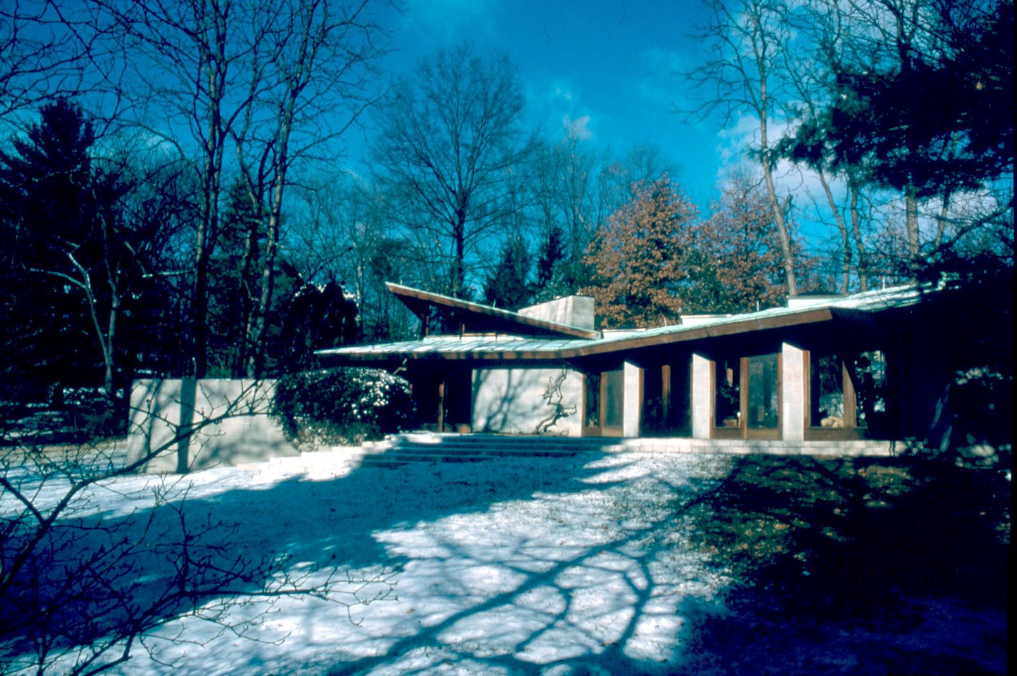
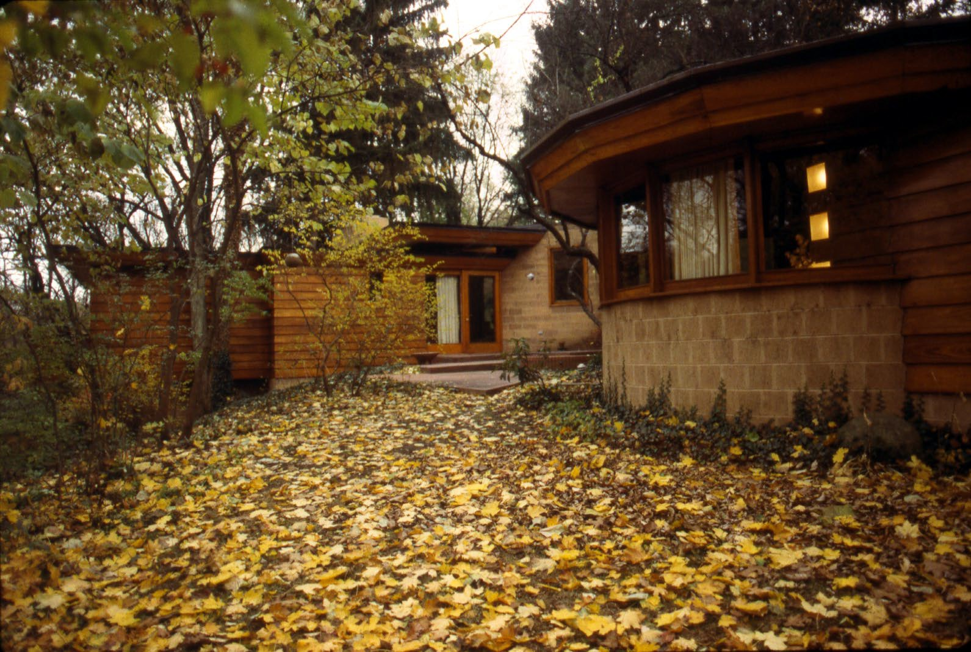

EXPERIENCING RUSH CREEK VILLAGE - 3

