
ARTS AND SCIENCES DIVISION
Languages & Communication

COURSE NUMBER: Chinese 1103 COURSE TITLE: Beginning Chinese III

CREDITS: 4

PRE-REQUISITES: Placement into ENGL 1101, CHIN 1102

COURSE DESCRIPTION:
The focus of Chinese 2201 is to move students beyond the beginning level and further develop their ability to function in Chinese culture using Mandarin as the primary language. The course emphasizes continued growth in communication across ethnic, cultural, ideological, and national boundaries while strengthening understanding of Chinese interpersonal behavioral culture and related thought patterns. Students will expand their skills in Chinese grammar, pronunciation, listening, speaking, reading, writing, and cultural interpretation at an early intermediate level.

COURSE LEARNING OUTCOMES:
At the end of the course, students will be expected to:
• Demonstrate greater fluency and accuracy in spoken Mandarin, including the ability to sustain conversations on familiar topics using a broader range of vocabulary and structures.
• Read and interpret short to moderately complex Chinese texts and respond appropriately at a level of proficiency suitable for continuing in the language sequence.
• Write Chinese characters and short connected passages with increased control of grammar, sentence patterns, and organization.
• Demonstrate cultural understanding appropriate to effective communication in Chinese, including the ability to recognize and apply culturally appropriate language and behavior in a variety of contexts.
OT36 LEARNING OUTCOMES: Not applicable
TAG LEARNING OUTCOMES: Not applicable

COURSE MATERIALS:
Use department-approved materials appropriate to the third course in the Chinese sequence.

STANDARDS AND METHODS FOR EVALUATION:
Your grades in the course are determined by classroom performance - dialog check and drill check. Daily performance on the activities assigned in the weekly schedule will be graded on the following four-point scale unless indicated otherwise:
  - 4 = Performance that promises interaction with a native with no difficulty, discomfort, or misunderstanding; no hesitation noise in speaking and no “foreignisms” in the written work
  - 3.5 = Performance comprehensible to native speakers, but some non-patterned errors that would hinder smooth interaction with them
  - 3 = Performance comprehensible to a native, but evident weakness or patterned error
  - 2.5 = Communication requires much help from the interlocutor.
  - 2 = Performance puts burden on the interlocutor. To facilitate communication, an English-speaking native would avoid using Chinese with you.
  - 1.5 = Barely prepared, little competency evident
  - 1 = Evidently unprepared, unable to perform
  - 0 = Absent

Most class sessions will be graded on a scale of 8 possible points. Grades will be kept for every assigned performance. You will need a minimum of 75% to pass the course.

GRADING SCALE:
A = 90% - 100%
B = 80% - 89%
C = 75% - 79%
D = 60% - 74%
E = 59 and below

COLLEGE SYLLABUS STATEMENTS

Columbus State Community College required College Syllabus Statements on College Policies and Student Support Services can be found at www.cscc.edu/syllabus or on the College website Quick Links “Syllabus Statements”.

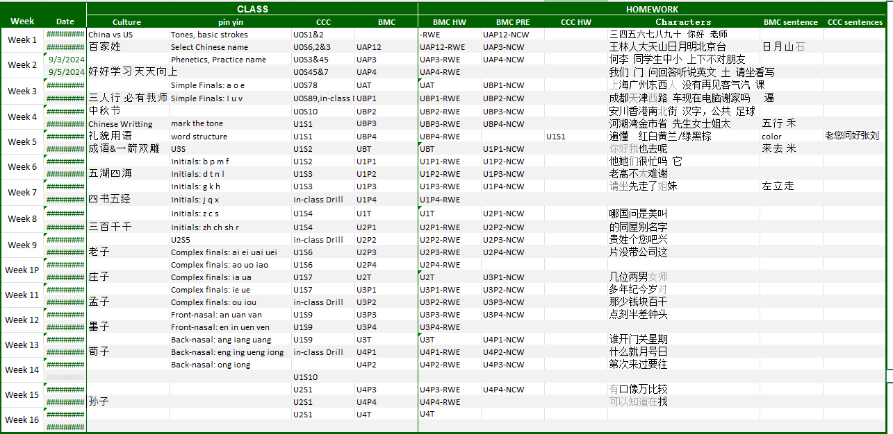
Course Calendar

