
ARTS AND SCIENCES DIVISION
Languages & Communication

COURSE NUMBER: Chinese 1102 COURSE TITLE: Beginning Chinese II

CREDITS: 4

PRE-REQUISITES: Placement into ENGL 1101, CHIN 1101

COURSE DESCRIPTION:
The focus of Chinese 1102 is to build on the foundation established in Chinese 1101 and help students function more successfully at the novice level in Chinese culture using Mandarin as the primary language. The course further develops students’ ability to communicate across ethnic, cultural, ideological, and national boundaries while deepening their understanding of Chinese interpersonal behavioral culture and related thought patterns. Students will continue to develop skills in Chinese grammar, pronunciation, listening, speaking, reading, writing, and culture.

COURSE LEARNING OUTCOMES:
At the end of the course, students will be expected to:
• Demonstrate increased control of the sound system of Mandarin Chinese and use Pinyin accurately to support pronunciation and comprehension.
• Successfully participate in increasingly complex basic conversations and interpret short Chinese texts at a level of proficiency appropriate for continuing on to the next course in the sequence.
• Read and write an expanded number of Chinese characters and apply fundamental grammatical patterns with greater accuracy and fluency.
• Demonstrate an increased level of cultural understanding suitable for correct performance of assigned tasks in Chinese, including appropriate language use and behavior in culturally relevant contexts.
OT36 LEARNING OUTCOMES: Not applicable
TAG LEARNING OUTCOMES: Not applicable

COURSE MATERIALS:
- Walker, Galal, Lang, Yong: Chinese: Communicating in the Culture Volumes 1
(Buy this immediately!) ISBN 0-87415-352-2.
- Kubler, Cornelius: Basic Mandarin Chinese, Reading and Writing, Text
(ISBN 978-0-8048-4726-1), and Practice Book (ISBN 978-0-8048-4727-8)

STANDARDS AND METHODS FOR EVALUATION:
Your grades in the course are determined by classroom performance - dialog check and drill check. Daily performance on the activities assigned in the weekly schedule will be graded on the following four-point scale unless indicated otherwise:
  - 4 = Performance that promises interaction with a native with no difficulty, discomfort, or misunderstanding; no hesitation noise in speaking and no “foreignisms” in the written work
  - 3.5 = Performance comprehensible to native speakers, but some non-patterned errors that would hinder smooth interaction with them
  - 3 = Performance comprehensible to a native, but evident weakness or patterned error
  - 2.5 = Communication requires much help from the interlocutor.
  - 2 = Performance puts burden on the interlocutor. To facilitate communication, an English-speaking native would avoid using Chinese with you.
  - 1.5 = Barely prepared, little competency evident
  - 1 = Evidently unprepared, unable to perform
  - 0 = Absent

Most class sessions will be graded on a scale of 8 possible points. Grades will be kept for every assigned performance. You will need a minimum of 75% to pass the course.

GRADING SCALE:
A = 90% - 100%
B = 80% - 89%
C = 75% - 79%
D = 60% - 74%
E = 59 and below

COLLEGE SYLLABUS STATEMENTS

Columbus State Community College required College Syllabus Statements on College Policies and Student Support Services can be found at www.cscc.edu/syllabus or on the College website Quick Links “Syllabus Statements”.

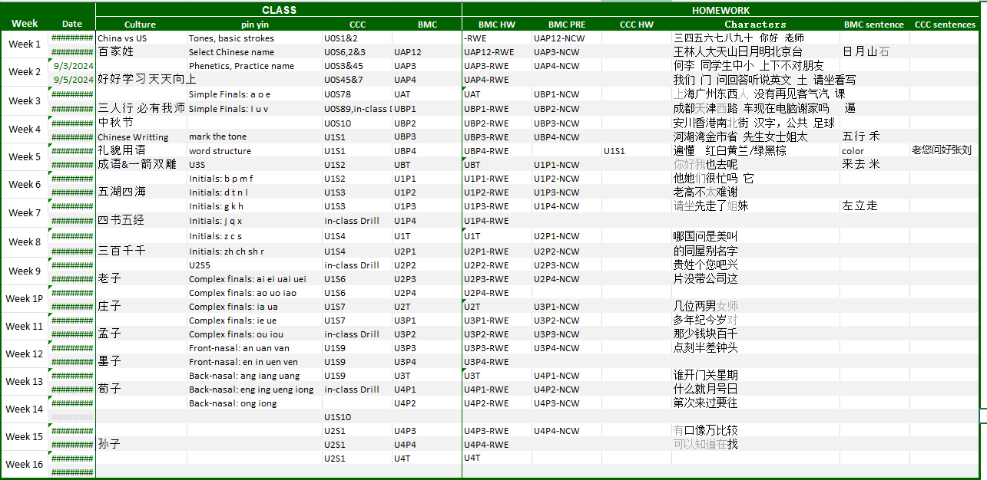
Course Calendar

