
ARTS AND SCIENCES DIVISION
Languages & Communication

COURSE NUMBER: Chinese 1101 COURSE TITLE: Beginning Chinese I

CREDITS: 4

PRE-REQUISITES: Placement into ENGL 1101

COURSE DESCRIPTION:
The focus of Chinese 1101 is to train students to function successfully at a beginning level in Chinese culture using Mandarin as your primary language. To do this, the class helps students to develop skills in Mandarin Chinese to communicate across ethnic, cultural, ideological and national boundaries and to develop an understanding of Chinese interpersonal behavioral culture and related thought patterns. Students will focus on Chinese grammar, pronunciation, writing skills and culture topics.

COURSE LEARNING OUTCOMES:
At the end of the course, students will be expected to:
- Learn the sound system of Mandarin Chinese and writing it in Pinyin.
- Successfully perform in basic conversations, reading simple Chinese texts, and writing Chinese characters at a level of proficiency appropriate for continuing on to the next course in the sequence.
- Be familiar with the basics of the spoken language, the class will introduce the writing system.
- Demonstrate a level of cultural understanding suitable for correct performance of assigned tasks in Chinese. This means that this class will pay attention to the way students behave as much as attending to students’ use of the language.

OT36 LEARNING OUTCOMES: Not applicable
TAG LEARNING OUTCOMES: Not applicable

COURSE MATERIALS:
- Walker, Galal, Lang, Yong: Chinese: Communicating in the Culture Volumes 1
(Buy this immediately!) ISBN 0-87415-352-2.
- Kubler, Cornelius: Basic Mandarin Chinese, Reading and Writing, Text
(ISBN 978-0-8048-4726-1), and Practice Book (ISBN 978-0-8048-4727-8)

STANDARDS AND METHODS FOR EVALUATION:
Your grades in the course are determined by classroom performance - dialog check and drill check. Daily performance on the activities assigned in the weekly schedule will be graded on the following four-point scale unless indicated otherwise:
  - 4 = Performance that promises interaction with a native with no difficulty, discomfort, or misunderstanding; no hesitation noise in speaking and no “foreignisms” in the written work
  - 3.5 = Performance comprehensible to native speakers, but some non-patterned errors that would hinder smooth interaction with them
  - 3 = Performance comprehensible to a native, but evident weakness or patterned error
  - 2.5 = Communication requires much help from the interlocutor.
  - 2 = Performance puts burden on the interlocutor. To facilitate communication, an English-speaking native would avoid using Chinese with you.
  - 1.5 = Barely prepared, little competency evident
  - 1 = Evidently unprepared, unable to perform
  - 0 = Absent

Most class sessions will be graded on a scale of 8 possible points. Grades will be kept for every assigned performance. You will need a minimum of 75% to pass the course.

GRADING SCALE:
A = 90% - 100%
B = 80% - 89%
C = 75% - 79%
D = 60% - 74%
E = 59 and below

COLLEGE SYLLABUS STATEMENTS

Columbus State Community College required College Syllabus Statements on College Policies and Student Support Services can be found at www.cscc.edu/syllabus or on the College website Quick Links “Syllabus Statements”.

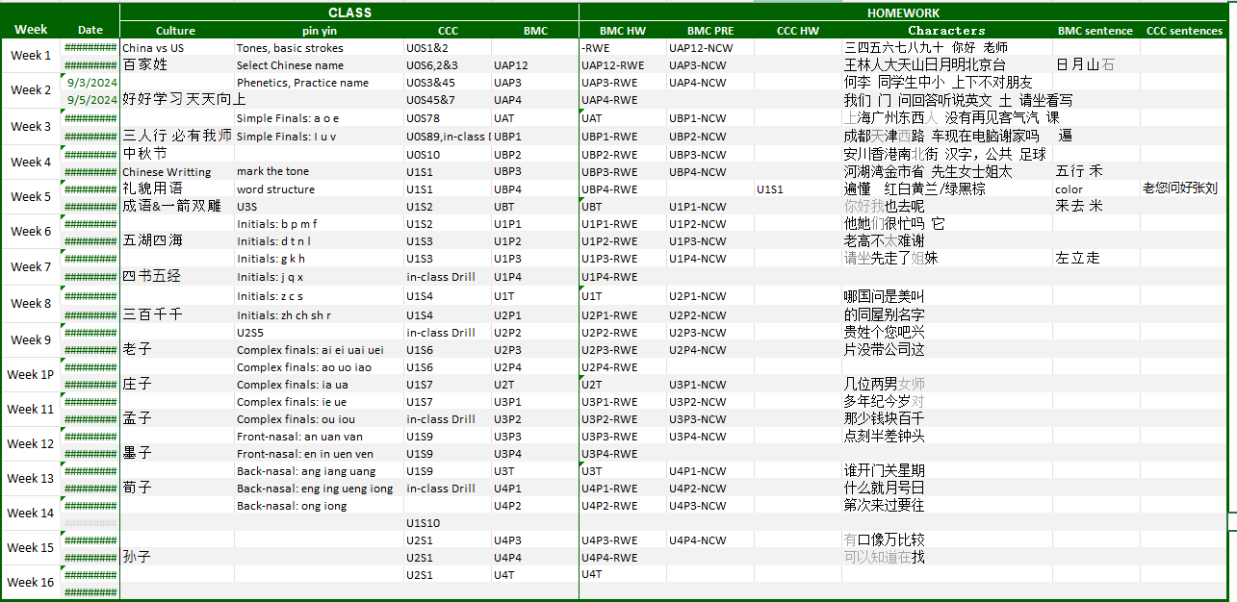
Course Calendar

