Redeeming Your Single Access Code and Student Self-Enrollment Instructions
- Access Code provided in the Textbook Custom Package “AUG'19 ColumbusStateCC_ADN_NewCurr-Sem1_eOnly” at Bookstore
Please follow the steps below to redeem your Custom Package Access Code on the Evolve website.
- Go to the Evolve website: https://evolve.elsevier.com/student
- Enter the Access Code/Card that was included in your “Textbook Custom Package” in option for “Redeem an Access Code or Enter an Evolve Course ID” and click “Submit”. Your custom package access code will give you access to the following online courses:
- Clinical Skills: Essentials Collection, 1st Edition
- EAQ for Fundamentals of Nursing - Classic, 9th Ed
- Nursing Concepts Online for RN 2.0 - Classic Version
- EAQ for Basic Pharmacology for Nurses - Classic, 18th Ed
- EAQ for Medical-Surgical Nursing - Nursing Concepts - Classic Version 10th Ed
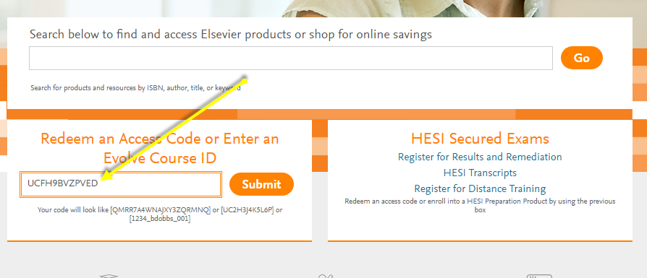
- You will see all items within your access code. Click Redeem
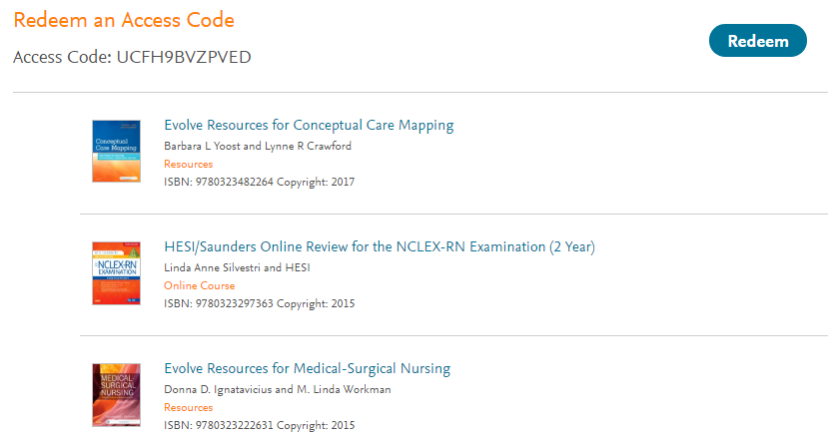

- Next, you will be prompted to “login” to your existing Evolve account, please do so now.
  - Only if you do not already have an Evolve account, then you can choose the option for “Create a New Account”.
  - If you forgot your username and/or password or cannot login to your account, please see the note at the end of this document ***NOTE***
- If your custom package includes eBooks, first time eBook users will be prompted now to create your “Vitalsource/Elsevier eBook Library” account:
    - Follow prompts to set-up your eBook library account: This will be different login details than your Evolve account. When you have finished setting up your eBook account details, your “Vitalsource/Elsevier eBook Library” account “username and password” will be sent to you via email.
- NEXT, Time to Self-Enroll into Your Required Online Courses. Enter your instructor’s Online Course ID and follow instructions listed in “6 - a”:
- SP 2021 Grads - EAQ Fundamentals of Nursing, 9th Ed
    - Course ID: 160221_pallen133_1011
- SP 2021 Grads – EAQ for Medical-Surgical Nursing - Nursing Concepts 10th Ed
    - Course ID: 161486_pallen133_1003
- SP 2021 Grads Nursing Concepts Online (NCO)
    - Course ID: 161374_pallen133_1009
- SP 2021 Grads – EAQ for Basic Pharmacology for Nurses, 18 Ed
    - 161826_pallen133_1001
- Clinical Skills: Essentials Collection, 1st Edition
    - Select Option for “Self-Study”
  - Enter Course ID above in the box for “Redeem an Access Code or Enter an Evolve Course ID” and click “Submit”. Now you will be automatically enrolled into your instructor’s course. You have completed the steps to ensure you have properly enrolled into your instructor’s online course!
- You now have access to your required Elsevier materials and you will be able to complete and access your required assignments/course materials. Please watch all below videos for an overview of each of the Evolve products.

- For any questions or additional assistance relating to anything offered on the Evolve website please contact Evolve Custom Support. You can send an email to the support team directly from the “Help” tab within Evolve (you would just select the Evolve product that this is relating to) or directly from the below link:
https://service.elsevier.com/app/overview/evolve/

- If you prefer to talk to someone live on this, please contact Custom Support at 1-800-222-9570

***NOTE***
ONLY If you already have/had an Evolve account but not able to login like you previously could, DO NOT CREATE A NEW ACCOUNT. Please contact 1-800-222-9570 and let the “Customer Support” person know that you cannot login to your Evolve account as this may need to be re-activated.

Product Overview and Additional Training Materials
Elsevier eBooks
- eBook NSO Video Recording:
https://elsevier.zoom.us/recording/share/C91Zv89AupIliauEeP6Ygi7RTELgf64YQAIgSO_AL0SwIumekTziMw?startTime=1534861101000

Additional Training Available: Click on your “My Evolve” tab. You will then see an option listed for “Elsevier eBook Library” on VitalSource (eBook software provider). This is where you can go to access eBook online library.

You can download your eBook library so that you can access this without internet access. To do so, please refer to the below extremely helpful “eBook Training Tutorial”:
http://downloads.vitalbook.com/tutorials/publish/index.html?did=elsevier#video/elsevier_downloadable_app_inside_book_hilites_notes
- Within the training video there is a section for “Elsevier eBook Downloadable” that
includes direction on how to download the “app” for this.

Clinical Skills: Essentials Collection
- CS-Essentials NSO Video Recording:

https://elsevier.zoom.us/recording/share/NuuEqaFTJvbh_XB7Qiy1ssxatAtX8BNO3VB182U4C1U?startTime=1534858010000
Additional Training Available:
Please go to the “Student Resources” listed under the “Course” tab on the left navigation bar within this course. Then please orient yourself with what is available in the “Student Resources” for additional details:
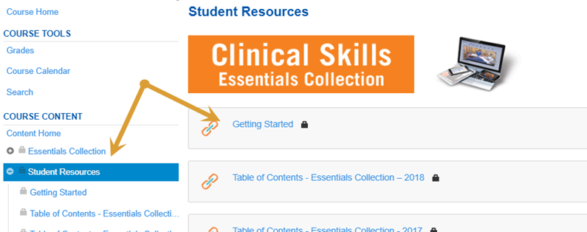
Nursing Concepts Online
- NCO-RN (LPN/LVN functionality same) Student Orientation – Video Recording: https://elsevier.zoom.us/recording/share/v6pHDicTDXG_WGn-5OyC2iHzGAHGxk19bbZjyjCvh8uwIumekTziMw
Elsevier Adaptive Quizzing
- EAQ NSO Video Recording:
https://elsevier.zoom.us/recording/share/FigUcMoYl0asFkKlGx-VjCYY7D9M9sVF2pKoW5l2qjOwIumekTziMw?startTime=1534877674000

EAQ Overview: https://evolve.elsevier.com/studentlife/video/adaptive-walk-through.html

Additional Training Available: Go into your Adaptive Course, see the option for “Help” located in upper right corner of your course. Click on the option titled “FAQ/Resources” (see below) to access the most commonly asked questions from students.
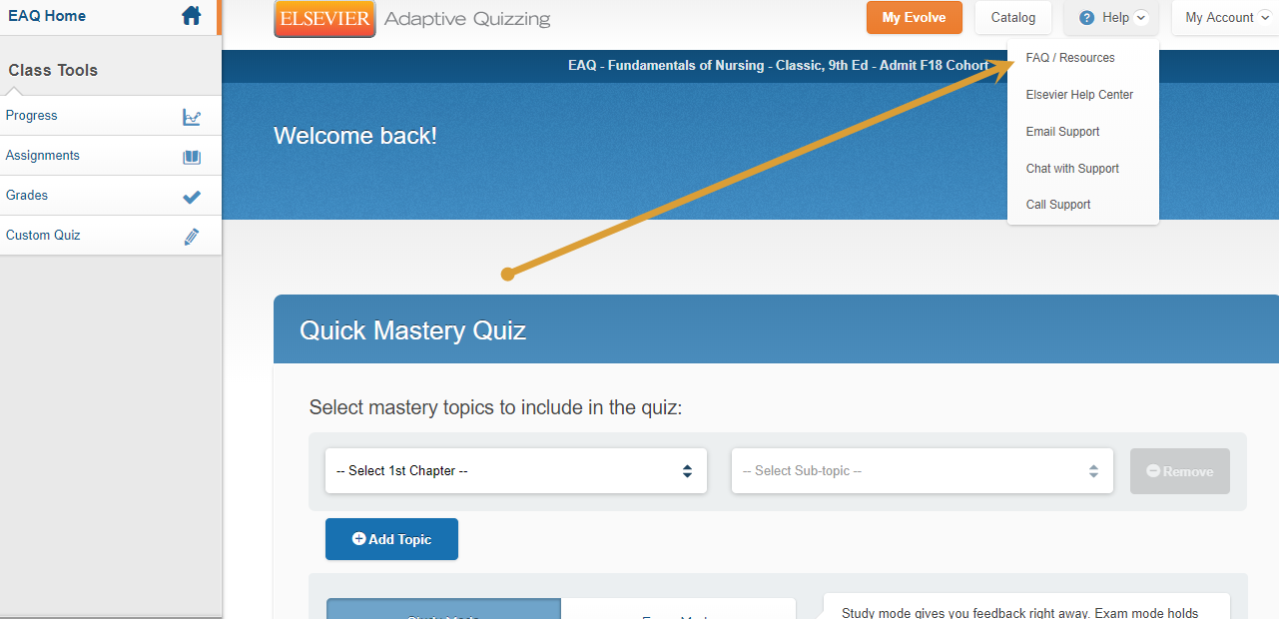

Additional Details Available for All Evolve Products: On the “Elsevier Student Life” website. Simply go to the Evolve “Catalog” home page. Scroll down and click on icon for “Elsevier Student Life”:
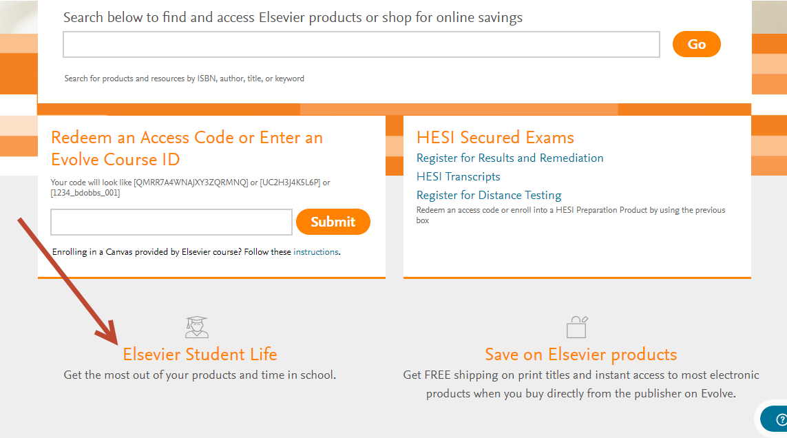
While on the “Elsevier Student Life” website go to the top of the page and select which Evolve/Elsevier products you will like more information on and then scroll down to see what is available:
